MODULE 1- HOW CAN YOU CREATE AN EFFECTIVE LEARNING ENVIRONMENT?

SESSION 2: DEVELOPING MOTIVATION

Welcome to the core session on Developing motivation.
This session should take around 45 minutes to complete.

Session overview
It’s important to create a culture of trust and respect within your classroom that supports all pupils to be motivated and to succeed.
Whilst both intrinsic and extrinsic motivation are important, pupils tend to enjoy learning and do better when they are more intrinsically than extrinsically motivated to achieve. Therefore, you should help pupils on their journey from needing extrinsic motivation to being motivated to work intrinsically.
To support you to do this, in this session you will explore:
- motivation
- using praise
- building trust and respect
- what determines intrinsic motivation?
- how you can develop motivation, by:
  - providing opportunities for pupils to experience meaningful success
  - creating an environment where it’s safe to make mistakes
  - generating buy-in.

Extrinsic and intrinsic motivation
Pupils are motivated by extrinsic factors (related to rewards) and intrinsic factors (related to their identity and values).
EXTRINSIC FACTORS
Extrinsic factors are external motivators, such as rewards and punishments. Therefore, an extrinsically motivated pupil is likely to persist at a challenging task because they want to receive a reward such as a house point, sticker, or praise, or they want to avoid punishment, like a detention or extra homework.
When using rewards and sanctions as extrinsic motivators, it’s important these are used consistently and in line with your school policies. In doing so, this will support in creating a predictable and safe learning environment for pupils. In the next session, you’ll look further at the importance of consistency when applying consequences and sanctions.
INTRINSIC FACTORS
Intrinsic factors are internal motivators which relate to an individual’s identity and values. As a teacher, you are a key role model, who can influence the attitudes, values, and consequently, behaviours of your pupils. For example, you might emphasise the value of persevering in the face of adversity because in order to improve at something, you must practise areas that you find challenging. Therefore, an intrinsically motivated pupil may be likely to persist at a challenging task because they know you need to practise to improve as a result of the values you have been promoting.
As teachers, our long-term aim is to help our pupils move from needing extrinsic motivation to being intrinsically motivated to work and learn.

Developing a supportive environment
When considering how we can develop pupil motivation, it is key that we first consider the classroom environment and the important role that relationships play.
Creating a calm and respectful classroom environment is a bedrock on which you can build positive relationships with your pupils and in turn improve their wellbeing, motivation and behaviour.
“Effective teaching and learning requires positive relationships and interactions between teachers and pupils”

Using praise effectively
As teachers, we can demonstrate our consistently high expectations by acknowledging and praising pupil effort and emphasising the progress pupils are making by using intentional and consistent language which promotes challenge and aspiration. This can help to communicate shared values that improve both the classroom and school culture.
Praise can be used to positively reinforce expectations and to recognise pupils’ hard work and effort, sharing and celebrating their work or behaviour. This can be useful in encouraging positive behaviours and can improve pupils’ motivation, behaviour and learning (EEF, 2021).
Whilst acknowledging and praising pupil effort and progress is a great way to extrinsically motivate pupils, research suggests that praise, when used well, can also help to build intrinsic motivation (Henderlong & Lepper, 2002).
However, overusing praise can make it seem disingenuous to pupils, losing its effect. To avoid overuse, it can be helpful to keep in mind the difference between acknowledgement and praise, and to consider how to make praise most effective.
ACKNOWLEDGEMENT
This is when you recognise or thank a pupil for meeting your expectations. For example: “Thanks Suzy for lining up silently”, or “I can see 80% of us are ready to start.”
OVERUSE OF PRAISE
This is when you praise pupils for meeting expectations. For example: “Wow, Suzy is lining up silently. Fantastic!” This should be avoided as it sends a message that you’re impressed that Suzy has met expectations, and perhaps you hadn’t expected her to.
PRECISE PRAISE
This is when praise is specific, so pupils know what they did well. It’s used to highlight effort, determination, or progress. For example: “Fantastic, Suzy. You’ve done a great job by showing your working on each problem.”
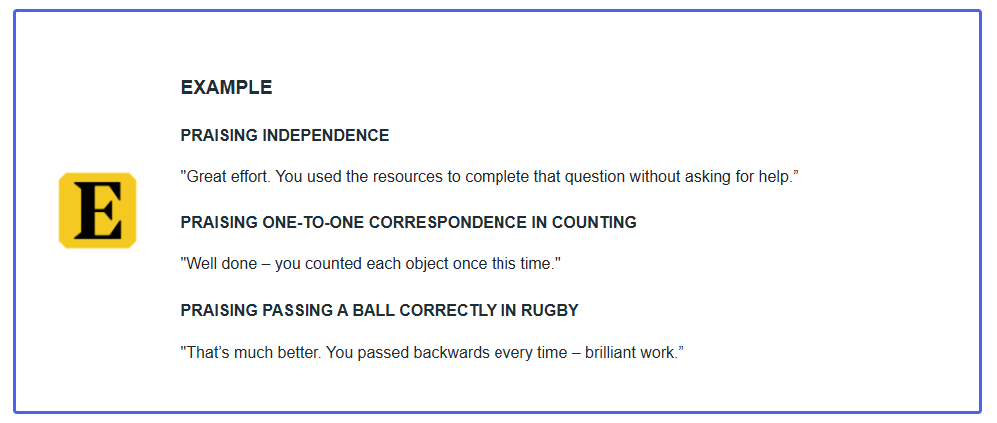

Precise praise and acknowledgement in action
Spend around 5 minutes on this activity.
Watch the video below most relevant to your context of a teacher using precise praise (to highlight pupil effort or progress) and acknowledgement (to highlight when their expectations have been met). Whilst watching, consider the following questions and make a note of your responses. You can record your reflections using the notes tab.
Does the teacher use acknowledgement or precise praise (or both) and what’s the impact on pupils?
Early Years video
Primary video
Secondary video
Special school video

Moving from extrinsic to intrinsic motivation
So, we know the goal is to move pupils from being extrinsically to intrinsically motivated. But how do we do this beyond praise?
Pupils’ intrinsic motivation is complex and is influenced by a multitude of factors such as:
- prior experiences, for example, within a given subject, or with a given teacher
- perception of success and failure – whether they view failure as a part of learning, and whether they believe their capabilities are fixed or under their control
Therefore, to develop pupils’ motivation, it can be effective to change their experiences and environment.
You can do this by:
- providing opportunities for pupils to experience meaningful success
- creating a positive learning environment where it’s safe to make mistakes
- generating buy-in by linking success in school to pupils’ long-term goals
Let’s start by looking at the importance of providing opportunities for pupils to experience meaningful success

Providing opportunities for meaningful success
As a teacher, you can influence your pupils’ resilience and beliefs about their ability to succeed by ensuring all pupils can experience meaningful success.
It’s important you consider the following when setting up pupils for meaningful success.
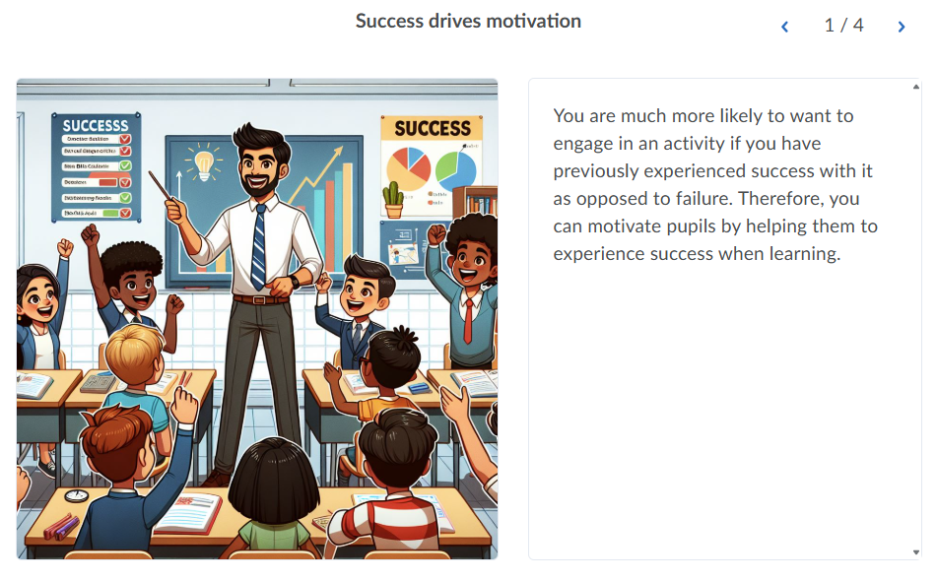

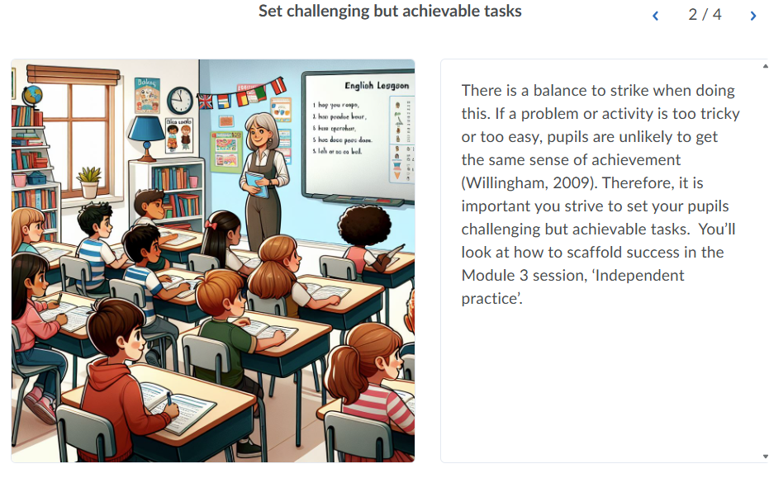
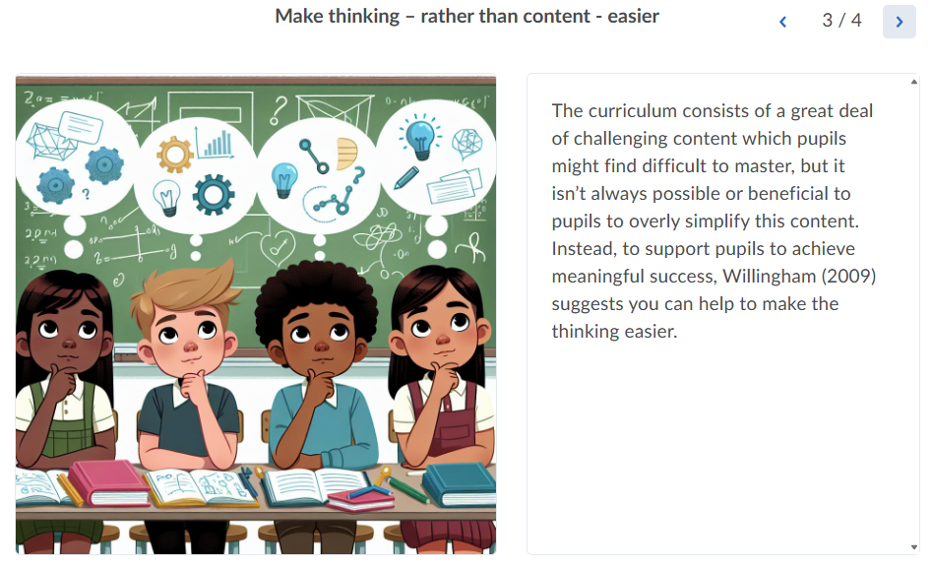

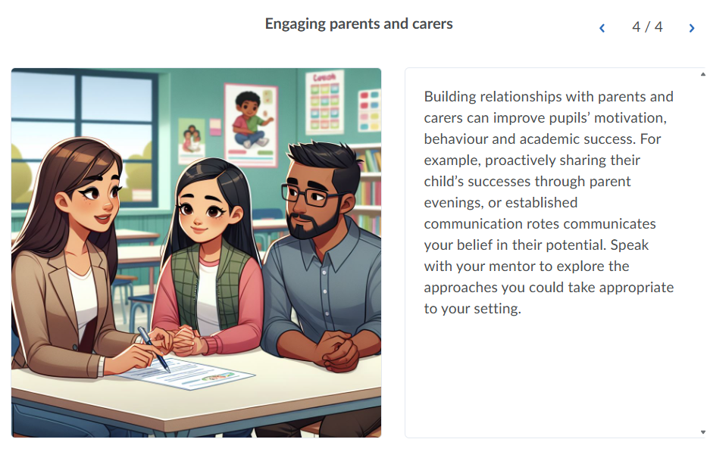

You’ll revisit the relationship between success and motivation further in your Module 3 session on practice.

Positive attitudes towards maths
One key area in which work is needed to develop pupils’ motivation through experiencing meaningful success is maths. Many pupils have negative attitudes towards maths and these usually get worse as pupils get older. For example, you’ll reveal that in one survey the percentage of pupils who reported they don’t like maths at Year 5 and Year 9 were (EEF, 2021):
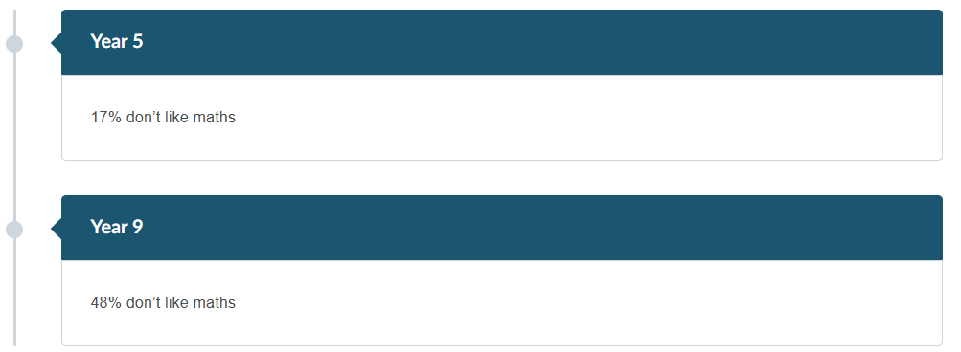
In their meta-analysis of the relationship between maths anxiety and maths achievement, Barroso et al. (2021) found that people who report higher feelings of anxiety toward maths tend to have lower maths achievement.
And Ofsted (2021) state: “Pupils are more likely to develop a positive attitude towards mathematics if they are successful in it, especially if they are aware of their success."
Therefore, it’s important to both ensure pupils experience meaningful success in maths and develop their perception of themselves as learners of maths.
Although not all teachers will be teachers of mathematics, mathematical literacy plays a crucial role in many subjects and in life. It’s therefore important all teachers model positive attitudes towards maths throughout the school.

How can you help pupils achieve meaningful success?
As we’ve explored it’s important to communicate a belief in the academic potential of all pupils by setting tasks that stretch and challenge pupils - but which are also achievable. There are multiple ways you can do this and ensure your pupils experience meaningful success - for example, through effective explanations, modelling, and scaffolding which takes into account pupils starting points. These approaches, as well as many more, will be explored in detail throughout this programme.

Making it safe to make mistakes
Just as feelings of success can lead to motivation, feelings of failure can lead to demotivation. When learning new concepts, there are likely to be times when pupils misunderstand something and make errors. In fact, this is often a critical part of learning. If pupils don’t recognise this as an important part of learning, and instead see this as failure, then it is likely to demotivate them from further engagement.
Creating a positive learning environment, where pupils feel safe to make mistakes, and recognising this as an important part of learning, is likely to increase their motivation to learn.
How can you create a positive environment where pupils feel safe to make mistakes?
There are a number of ways you can do this, for example:
- telling pupils that mistakes and misconceptions are a part of learning
- praising pupils for their effort and progress rather than whether they are correct or not
- where pupils have made public mistakes or errors, thank them for their answer and for allowing you to use their answer as a learning point for the class

Creating a positive learning environment in action
Spend around 5 minutes on this activity.
Watch the video of a teacher creating a positive learning environment where it's safe to make mistakes, most relevant to your context. Consider the following questions and make a note of your responses. You can record your reflections using the notes tab.
How does the teacher create an environment in which it’s safe to make mistakes and what impact did this have on pupils?
Early Years video
Primary video
Secondary video
Post-16 video
Special school video

Generating buy in
People are intrinsically motivated when they have autonomy over what they do and are given meaningful choices about what they engage with. However, in the classroom setting, it is difficult to present pupils with choice over what they learn or how. This is because they are novices and are therefore perhaps not best placed to make those decisions.

So how can you develop buy-in?
We can generate buy-in by linking success in school to pupils' long-term goals. To do this you can:
- find out about pupils’ future goals and aspirations
- explain to pupils why they are engaging in certain tasks and activities and help them see how their success in school is related to achieving their long-term goals
- show pupils the journey of their learning and how different topics and subjects will build upon each other throughout the year and their school journey. Some schools use curriculum maps to do this
By providing pupils with opportunities to articulate their long-term goals and linking this to their success in school, you help to develop their intrinsic motivation to succeed.
Of course, it is also important you support pupils to achieve these, for example, by helping them to master challenging content which builds towards their long-term goals.
Let’s look at some examples. Select the heading relevant to your context.
EARLY YEARS AND PRIMARY

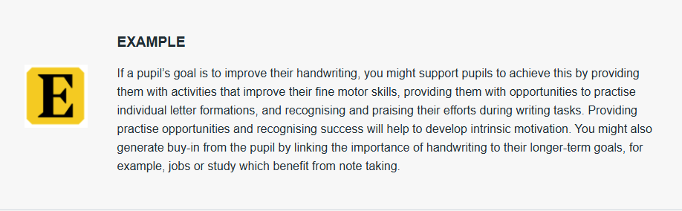

SECONDARY
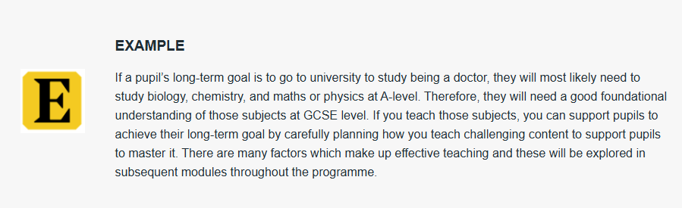

POST-16

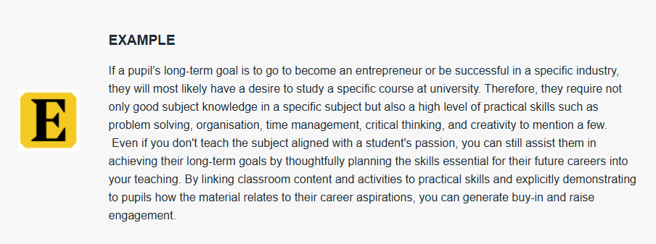

SPECIAL SCHOOLS
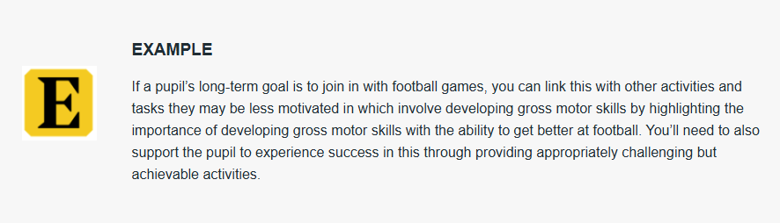

Mentor interaction: Approaches to developing motivation
In preparation for your next mentor interaction, your mentor may observe how you are building pupils’ motivation using one of the strategies covered in this session. As a reminder these were:
- using precise praise and/or acknowledgement
- providing opportunities for pupils to experience meaningful success
- creating a positive learning environment where it’s safe to make mistakes
- generating buy-in by linking success in school to pupils’ long-term goals

We suggest you focus on one of these approaches with your mentor.

PREPARATION
Spend around 5 minutes reflecting on the strategies you’ve explored and decide on which strategy would be highest leverage to implement or develop further in your practice and why.

References
Barroso, C., Ganley, C. M., McGraw, A. L., Geer, E. A., Hart, S. A., & Daucourt, M. C. (2021). A meta-analysis of the relation between math anxiety and math achievement(this link opens in a new window/tab). Psychological Bulletin, 147(2), 134–168.
Education Endowment Foundation (2021) Improving Behaviour in Schools Guidance Report(this link opens in a new window/tab)
Education Endowment Foundation (2021) Improving Mathematics in Key Stages 2 and 3 Guidance Report(this link opens in a new window/tab).
Education Endowment Foundation (2020) Special Educational Needs in Mainstream School Guidance Report(this link opens in a new window/tab).
Henderlong, J., & Lepper, M. R. (2002). The effects of praise on children's intrinsic motivation: A review and synthesis. Psychological Bulletin, 128(5), 774–795.
Ofsted (2021) Research review series: mathematics(this link opens in a new window/tab).
PISA (2015) PISA in Focus: Do teacher-pupil relations affect pupils’ well-being at school?(this link opens in a new window/tab)
Willingham, D. T. (2009). Why don’t students like school: because the mind is not designed for thinking. (this link opens in a new window/tab)American Educator, Spring, 4–13.

