MODULE 1- HOW CAN YOU CREATE AN EFFECTIVE LEARNING ENVIRONMENT?

SESSION 3: ADDRESSING LOW-LEVEL DISRUPTION

Welcome to the core session: Addressing low level disruption.
This unit should take around 45 minutes to complete.

Session overview

You can affect and improve the wellbeing, motivation and behaviour of your pupils. When behaviour incidents occur, no matter how small or large, it’s important you respond consistently in the least intrusive ways which align with your school’s behaviour policy and ethos.
To support you to do this, you will explore:
- what is low-level disruption?
- using early and least invasive interventions
- issuing consequences and sanctions

What is low level disruption?
As you’ve explored in your first two sessions, creating effective routines and developing pupils’ motivation can support you in preventing misbehaviour from occurring in the first place. However, when it does occur it’s important to address it as early as possible to prevent it from escalating and impacting further on pupils’ learning.
Low-level disruption can be anything that disrupts the flow of your lesson. Sometimes, a pupil’s attention may drift unintentionally, and they may begin to exhibit low-level disruption. On other occasions, pupils may deliberately exhibit such behaviours to avoid engaging with work or for a variety of other reasons.
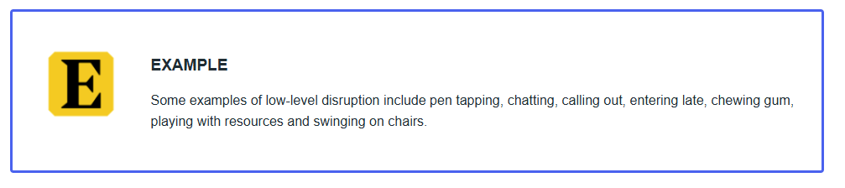

In isolation, low-level disruption can seem harmless. But when it occurs frequently, it can become increasingly difficult to manage, and this inevitably impacts on pupils’ learning.

Least invasive interventions
In response to low-level disruption, one approach we can take is to use the ‘Least Invasive Intervention’ (Lemov 2015; Lemov, 2021). Lemov argues that by minimising the ‘drama’ you can correct off-task pupils without interrupting the learning. In contrast, if you confront pupils too publicly, you may escalate a situation unnecessarily, and make a pupil feel embarrassed or shamed. This makes the situation worse for both you and the pupil – and is more likely to derail the learning of this pupil and others.
Lemov identifies six subtle techniques that a teacher can use to quickly address low-level disruption, which you will explore throughout this session. These techniques are listed below in order, with the least intrusive method at the top:
- Non-verbal intervention
- Positive group correction
- Anonymous individual correction
- Private individual correction
- Lightning-quick public correction
- Private individual praise

Which one should you choose?
In the classroom, you may choose to address low-level disruption by employing the least invasive technique first (non-verbal intervention) and work your way down the techniques if the previous one doesn’t work. However, there may be some occasions where you choose the method you feel is most appropriate to the context and the behaviour being exhibited at the time. We’ll explore each of these in more detail.

Least invasive interventions
These techniques are listed below in order, with the least intrusive method first. However, remember they should be applied as appropriate in response to the behaviour presented. Select each heading to learn more.
NON-VERBAL INTERVENTIONS
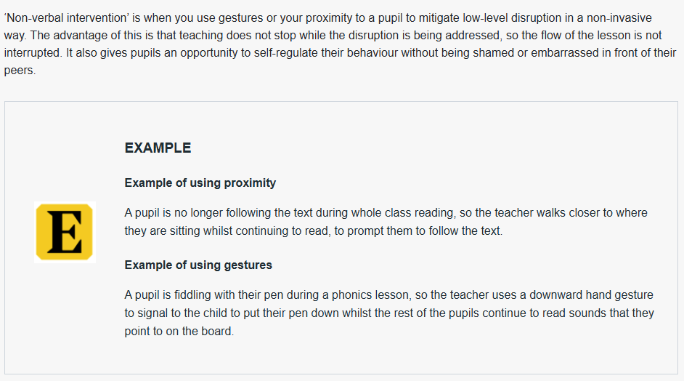

POSITIVE GROUP CORRECTION

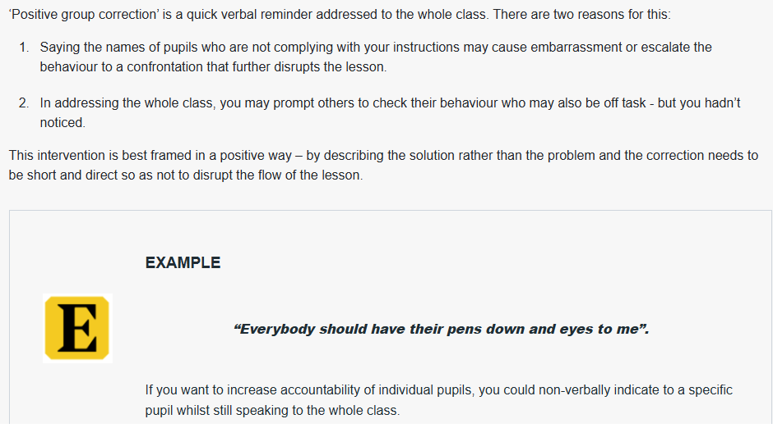

ANONYMOUS INDIVIDUAL CORRECTION
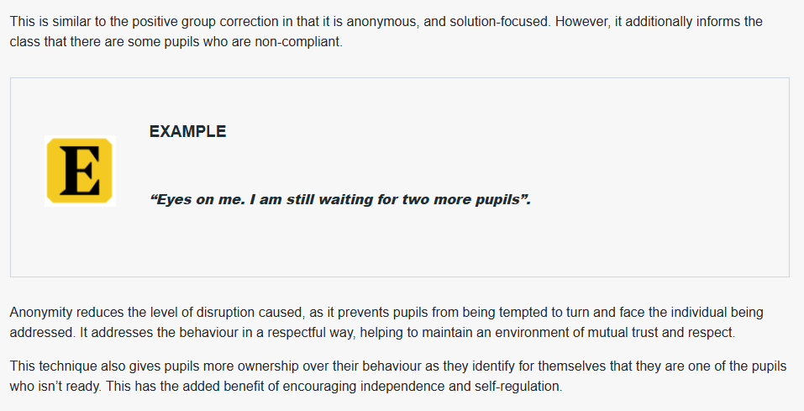

PRIVATE INDIVIDUAL CORRECTION
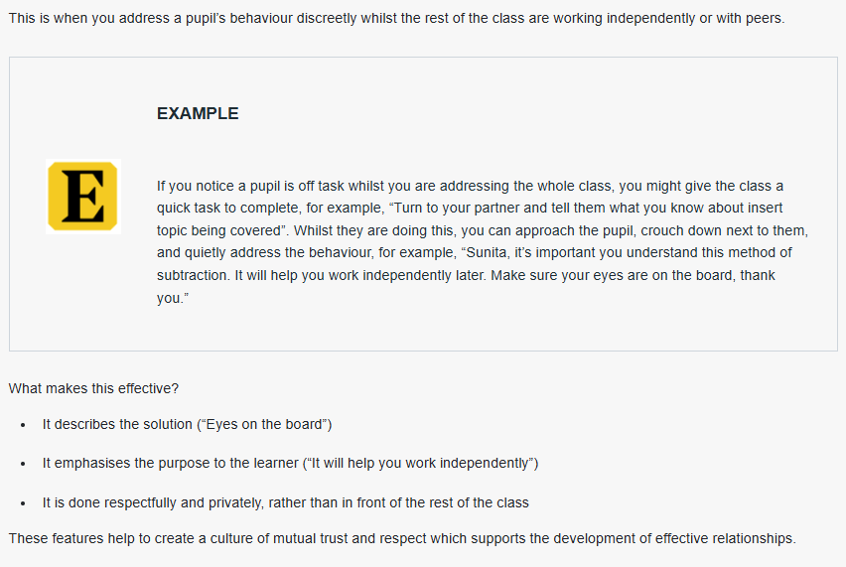

LIGHTNING-QUICK PUBLIC CORRECTION

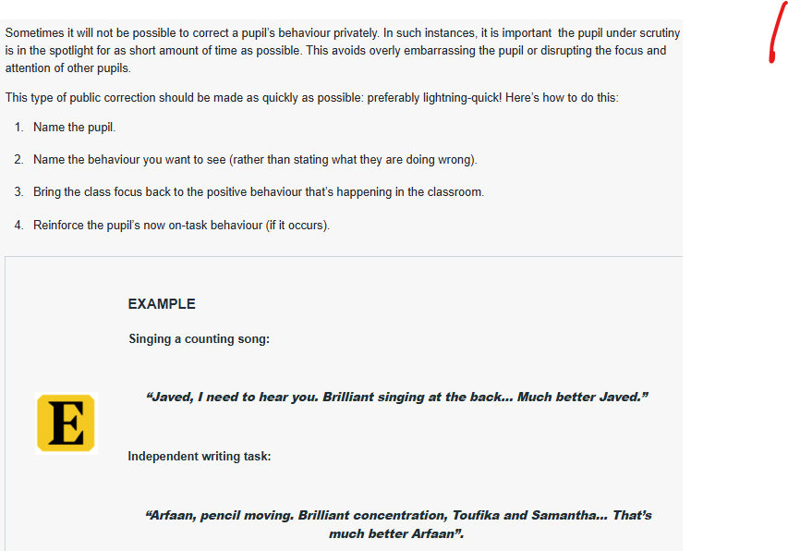

PRIVATE INDIVIDUAL PRECISE PRAISE

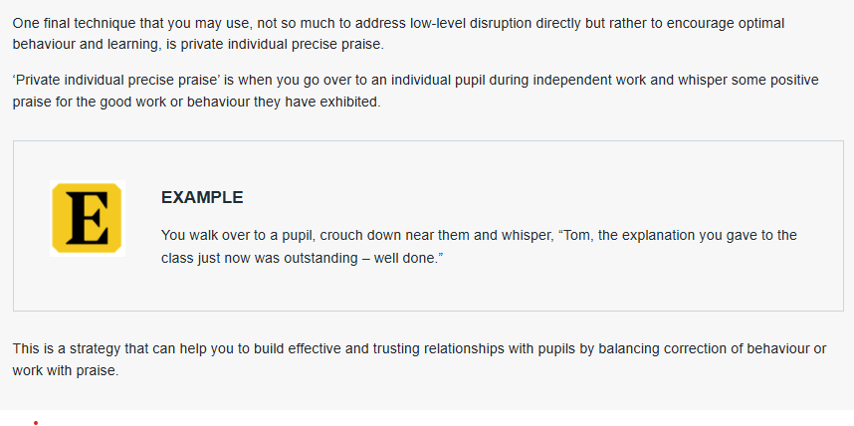

Least invasive interventions in action
Spend around 3 minutes on this activity.
Select one of the least invasive intervention techniques you’ve just explored by selecting the most relevant heading to your phase/context.
As you watch consider the impact the technique has on the pupil and on the classroom environment.
NON-VERBAL INTERACTION IN ACTION
Early years video
Primary video
Secondary video
Post-16 video
Special school video

POSITIVE GROUP CORRECTION IN ACTION

Early Years video
Primary video
Secondary video
Special school video

ANONYMOUS INDIVIDUAL CORRECTION IN ACTION

Early Years video
Primary video
Secondary video

PRIVATE INDIVIDUAL CORRECTION IN ACTION
Primary video
Secondary video
Post-16 video
Special school video

Consequences and sanctions
Now that we’ve looked at how to address low-level disruption, we’re going to look at what happens if that behaviour is continued or becomes more serious. When this happens, it will likely be necessary to put in place a consequence or sanction.
A consequence or sanction is used to reinforce the behavioural expectations that you set in your classroom and can communicate shared values that improve both classroom and school culture. Consequences should be used to educate pupils about which behaviours are and are not appropriate and should help them to learn that if they choose to be disruptive, they choose to face the consequences.
Different schools may approach consequences in different ways and will have a behaviour policy which outlines this. Because schools vary in their approach to behaviour management, we will focus here on how to issue consequences effectively rather than what type of consequence to issue.

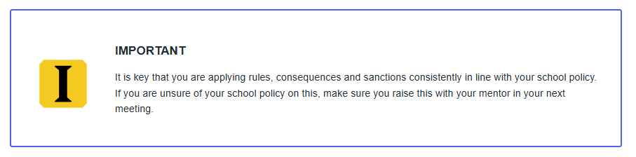

When issuing consequences, it is important to ensure disruption to learning is minimised and you try to maintain pupil-teacher relationships. Some ways you could do this is to ensure your consequences are:
- Consistent
- Depersonalised
- Deferred

Effectively issuing consequences
As you’ve explored, when issuing consequences, it is key that you follow your school’s behaviour policy. However, the following principles can apply regardless of the specific consequence or sanction being issued.

Consistent
It’s important you are consistent with the consequences you issue. For example, if you have decided that pupils talking when you are talking is something you won’t tolerate and will correct, then you must pick up on this behaviour every time and be consistent in how you address it. This helps to make a predictable and secure learning environment, which benefits all pupils but is particularly valuable for pupils with special educational needs.
Issuing consequences consistently is important but it’s equally important you follow through with them. For example, if you have issued a consequence to a pupil such as missing their break time, then it’s vital that they do otherwise they will learn that the consequences you issue are actually empty threats and are meaningless.

Hear from an expert
Spend around 5 minutes on this activity.
Listen to Tom Bennett discuss the importance of consistency in more detail and make notes on the following questions. You can record your reflections using the notes tool.
- Why is consistency important?
- How can you ensure you demonstrate consistency in your behavioural expectations?
- Why is it important to be consistent with the whole school community?

Video - The importance of clarity and consistency

Depersonalised
You’re a key role model, who can influence the attitudes, values and behaviours of your pupils. Therefore, when issuing consequences, it’s important you focus on the behaviour itself - and not on the pupil. This has several benefits.
IT IS LEAST INTRUSIVE
It refocuses the learning quickly by naming the negative behaviour and therefore encouraging the pupil to correct this.
IT HELPS MAINTAIN POSITIVE RELATIONSHIPS
It can establish a supportive and inclusive learning environment because you are labelling the behaviour rather than the pupil themselves.
IT MODELS POSITIVE BEHAVIOUR
It gives the opportunity to model courteous behaviour you would expect from pupils by demonstrating how to speak to individuals in a respectful way.
Here is what an example and non-example might look like in practice.

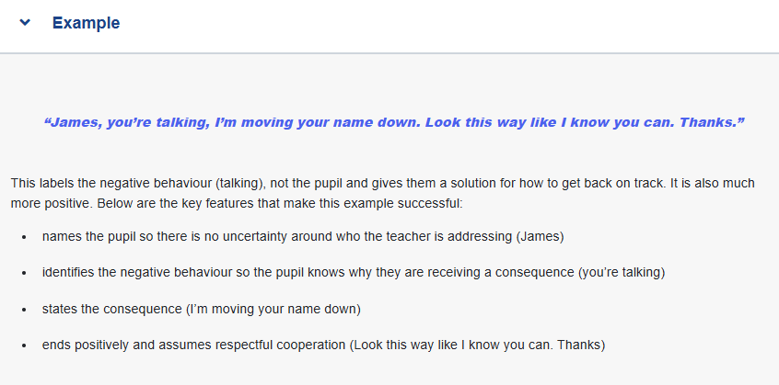

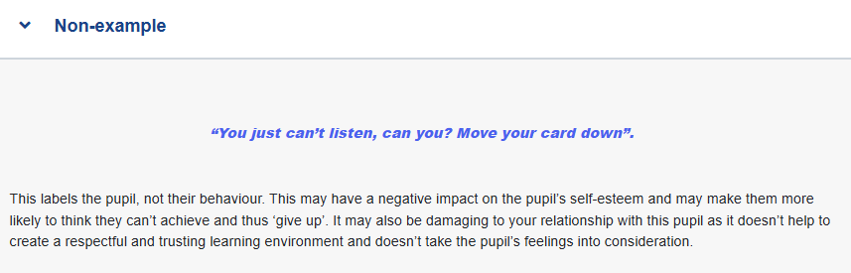

Deferred
The defining feature of a deferred consequence is that it places ownership on the pupil by giving them the option to follow your instructions or face a more severe consequence later.
Unlike the quick correction you might use to correct a behaviour first time round, a deferred consequence is more serious and will take place later – for example, at break time, lunch time, or after school.
This type of consequence should be used when a pupil continues to disrupt a lesson or to disobey your instructions and the consequence given should align with the behavioural policy or class sanctions you have set.
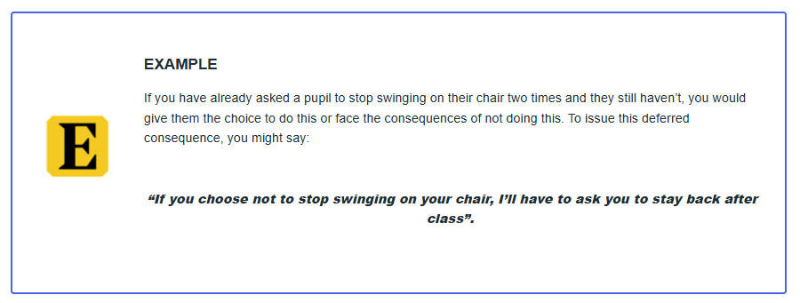

By giving pupils the choice, before issuing that more severe consequence, you give them the opportunity to correct their behaviour which supports their emotional and behavioural self-regulation which can impact upon their success at school and beyond.
If a pupil does not make the right choice, it is important you issue the deferred consequence and follow-up on it. By doing this, you are teaching pupils that you will be consistent in rigorously maintaining your behavioural expectations.

Issuing a consequence in action
Spend around 5 minutes on this activity.
Watch one of the videos below, most relevant to your context, of teachers issuing a consequence. Consider the following questions and make a note of your responses. You can record your reflections using the notes tab.
What makes the way in which the teacher issues the consequence effective? Consider how it is consistent, depersonalised and/or deferred.
Early Years video
Primary video
Secondary video
Special school video

Identifying the appropriate consequence
Knowing the appropriate consequences or sanctions to give for a certain behaviour can be tricky as behaviour is context specific and arises for a multitude of reasons meaning no one situation is the same.
It’s important to ensure consequences or sanctions are age appropriate. For example, pupils in early years are likely to benefit from consequences that are delivered immediately following the behaviour so the child can clearly connect the undesired behaviour to the consequence.

Dealing with more challenging behaviour
Beyond low-level disruption, it is also important to develop an understanding of how to deal with more challenging situations that may occur in your classroom so you can respond quickly to behaviour or bullying that threatens emotional safety. Such situations may include pupil refusal, swearing, racial abuse, or showing signs of aggression or physical abuse. If such incidences do arise, you need to know how to respond appropriately.
In the following session we’ll explore challenging behaviour in more detail.

Your right to support
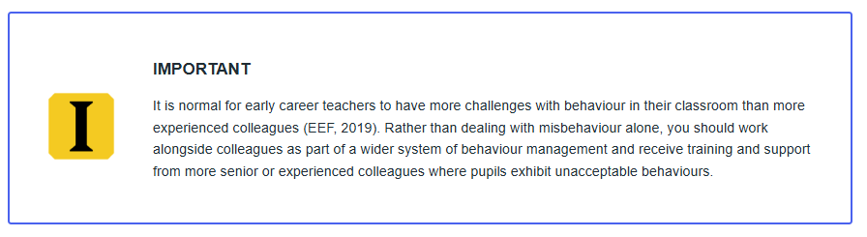

Mentor interaction: Least invasive interventions
In preparation for your next mentor interaction, your mentor may observe how you use positive and least invasive behaviour management strategies. To help you prepare, complete the activity below.
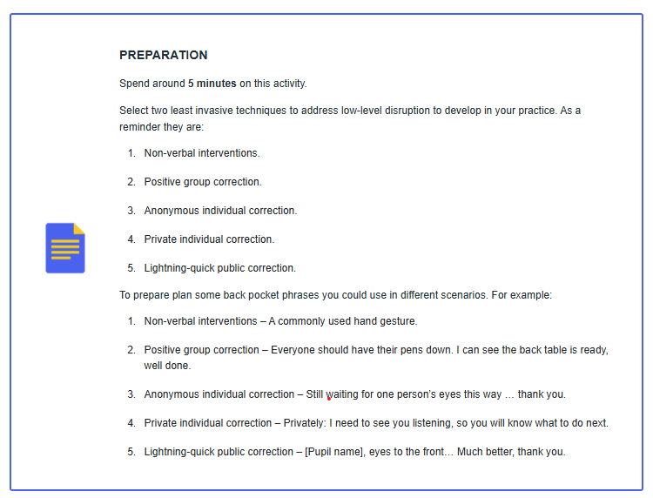

References
Education Endowment Foundation (2019) Improving behaviour in schools: Guidance report(this link opens in a new window/tab)
Lemov, D (2021). Teach like a champion 3.0. San Francisco: Jossey-Bass
Lemov D. and Atkins, N., (2015). Teach Like A Champion 2.0. San Francisco: Jossey-Bass

