MODULE 1- HOW CAN YOU CREATE AN EFFECTIVE LEARNING ENVIRONMENT?

SESSION 4: MANAGING COMPLEX BEHAVIOUR

Welcome to the core session on: Managing complex behaviour.
This session should take around 45 minutes to complete.

Session overview

In the previous session, you explored how to address low-level disruptive behaviour and the importance of issuing consequences in line with your school’s behaviour policy. Here we’ll look at understanding the influences on behaviour and how you could provide more tailored support to better manage pupil behaviour.
To support you to do this, in this session you will explore:
- influences on pupil behaviour
- tailoring support
- self-regulation
- working with parents and carers
- rebuilding and repairing relationships

Influences on behaviour
To be able to effectively manage complex or challenging behaviour, it’s important to first understand some of the key influences on pupil behaviour. Research tells us that teachers knowing their pupils well can have a positive impact on classroom behaviour (EEF, 2019a). And whilst every pupil’s motivations for their behaviour are unique and complex, there are some common factors to be aware of which can influence a pupils’ behaviour and their readiness to learn at school.

Home-life and circumstances
Pupils’ experiences of school and their readiness to learn can be impacted by their home life and circumstances, particularly for English as an additional language (EAL) pupils, young carers, and those living in poverty.
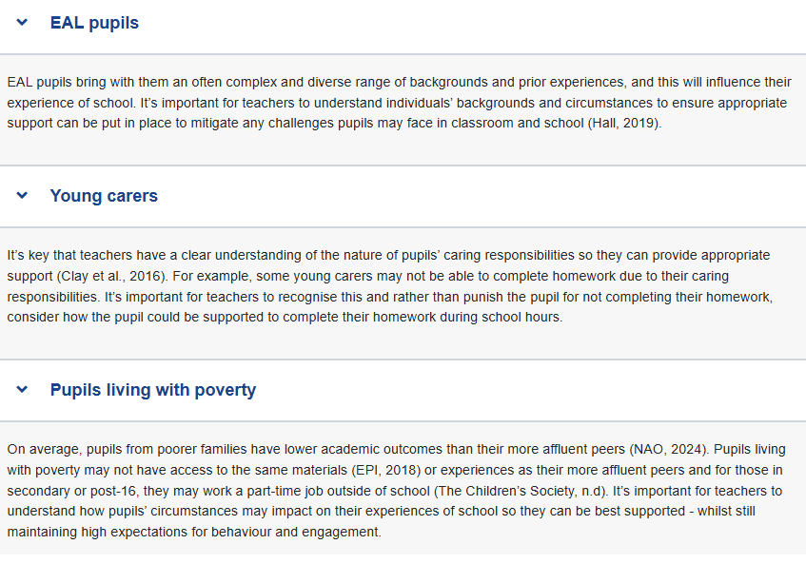

If a pupil has EAL, is a young carer, or is living with poverty, this does not mean they will necessarily require any support with their behaviour. However, it’s important to be aware of any challenges pupils’ unique circumstances may present, so they can be supported as best as possible.

Adverse childhood experiences (ACEs)
ACEs are significant negative events experienced during childhood or adolescence and can be direct, for example suffering from abuse or neglect, or indirect, for example the effects from a parent suffering mental illness or drug addiction. Research suggests ACEs have a harmful impact on a pupils’ later life and are strongly linked to social and emotional difficulties. They tend to affect pupils’ behaviour as well as their physical and mental health (EEF, 2019a).
Knowing about the trauma a pupil has experienced or is experiencing can help inform any tailored support a school provides and working with your school’s designated safeguarding lead and other relevant adults can help in ensuring the most appropriate support is in place.

Bullying
A key influence on a pupil’s behaviour is experiencing bullying. Being the victim of bullying is linked to negative effects on pupils’ mental health and lower attainment outcomes (EEF, 2019a). Teachers have a role to play in reducing instances of bullying as research shows effective classroom management can reduce challenging behaviour including bullying (EEF, 2019a). When bullying does occur, it is important you act quickly, following your school’s policies on this and escalating concerns as appropriate.
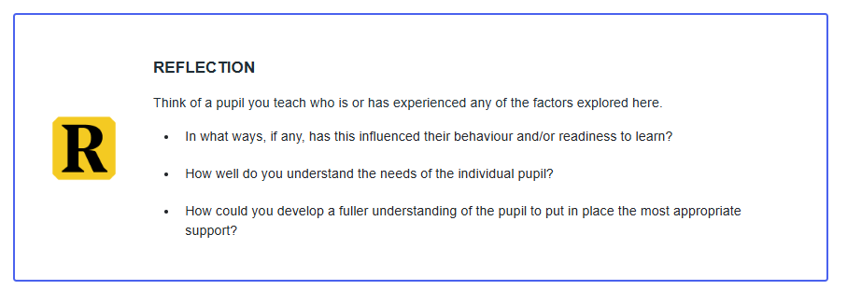

You should work with your SENCO, Designated Safeguarding Lead, pastoral lead and other expert colleagues to develop an understanding of your pupils where appropriate. Ensure you know who to contact with any safeguarding or mental health concerns. Speak to your mentor if you are unsure who this is in your school.

Importance of self-regulation
Another key area which influences pupils’ behaviour is their ability to self-regulate. When pupils are more aware of their own behaviour and can self-regulate, they are less likely to misbehave in the classroom (EEF, 2019a).
Self-regulation refers to the ability to recognise and manage our emotions and behaviours in different situations or contexts. This includes pupils being able to:
- regulate their reactions to different emotions
- calm themselves down after something exciting or upsetting
- focus on tasks and their learning
- manage and control their impulses
(EEF, 2019b)
Research shows that social and emotional skills including the ability to self-regulate is associated with pupils’ capacity to learn, their success in school and in future life - including health and wellbeing, job success and overall life satisfaction (EEF, 2019b).

Hear from a teacher
Watch this 4-minute video of Viki Dobbs, Early Years Lead at Teach First as she explains the importance of self-regulation and the impact on learning for young children. Whilst the video focuses on younger children, this understanding of self-regulation has implications across all ages of schooling.
As you watch consider what this means for the pupils in your class or context.
Video - Self-regulation

Who needs self-regulation instruction?
Teaching self-regulation skills to pupils of all ages - including older pupils - is valuable. Research shows that promoting social and emotional learning skills may be particularly important for pupils from disadvantaged backgrounds who often have poorer SEL skill than their more affluent counterparts. This is important when we consider that lower SEL skills are linked to poorer academic and mental health outcomes (EEF, 2019b).
We will now look at some specific approaches to developing pupils’ self-regulation.

Developing self-regulation
To effectively develop pupils' self-regulation, it’s important to explicitly teach, model, and provide practice of social, emotional, and behavioural norms as appropriate to pupils’ age and development. This can be achieved through a range of approaches - we’ll explore some of these below.
SUPPORT PUPILS TO THINK THROUGH SCENARIOS BEFORE THEY OCCUR
This could include using the following techniques:
- Role play using common scenarios. For example, if a common occurrence in your setting is pupils interrupting one another, you may wish to role-play this, supporting children to identify issues and how communication can be improved (EEF 2019b).
- Using social stories. These are often used to support autistic pupils to understand how to navigate different social situations in a way which is respectful of different perspectives and interpretations of the social world. For example, if a pupil struggles to understand how their behaviour impacts others, a social story can be used to help explain this. You may wish to explore social stories further: Carol Gray: Social Stories, (Opens in a new tab)
USING CUES TO RECALL AGREED BEHAVIOURS
These could include:
- non-verbal cues as you explored in the session ‘Addressing low level disruption’
- hand gestures as a subtle prompt, for example a hand gesture to prompt pupils to raise their hand before answering, or a signal for when they interrupt and need to wait their turn to speak
- picture cards as visual reminders of agreed behaviours, for example a display board with visual representations of classroom expectations or a feelings chart to support pupils to identify how they are feeling
- specific words or phrases which can be used when pupils may need a prompt to regulate their behaviour or emotions, for example, “Take a pause” for when a pupil may be feeling frustrated and needs to stop and think before responding.
It’s important any cues or prompts – and the behaviours they signify - are explicitly taught to pupils and that the same cue is used consistently to support habit development of the behaviour.

PROVIDE OPPORTUNITIES TO PRACTICE SELF-REGULATION SKILLS
This includes providing safe, low-stakes opportunities for pupils to practise key skills.
For example, if teaching children to take turns when speaking, provide them with explicitly planned opportunities to do this, such as providing time to practice using talk prompts for paired talk, as well as supporting them to embed this skill into other situations/contexts, such as a group discussion in a lesson.

Self-regulation in action
Spend around around 3 minutes on this activity.
Watch one of the following videos of a teacher explicitly developing pupils’ self-regulation, by selecting the heading most suitable to your phase below.
As you watch consider:
- which of the above approaches has the teacher used?
- how does their approach support pupils to develop their ability to self-regulate their behaviour and/or emotions?
- to what extent have you used a similar approach in your own practice?

Early Years video
Special schools video

OPTIONAL Reading
To learn more about how you can support pupils’ social and emotional learning you may wish to read the EEF’s Improving Social and Emotional Learning in Primary Schools guidance report(this link opens in a new window/tab).
This report reviews the best available research on SEL to provide 6 practical recommendations to support schools to implement effective SEL for all pupils.
As we’ve explored, the reasons for pupil behaviour are unique and complex, and therefore, universal behaviour systems are unlikely to meet the needs of all pupils. Some pupils therefore may need a more intensive or personalised approach to support behaviour.

Targeting support
For targeted support to be effective, it is key it’s tailored or adapted to the needs of the individual pupil. This means avoiding generic adaptations and instead making changes based on an understanding of the pupil’s context and needs.
Let’s look at an example where an intervention is not tailored to the pupils needs.
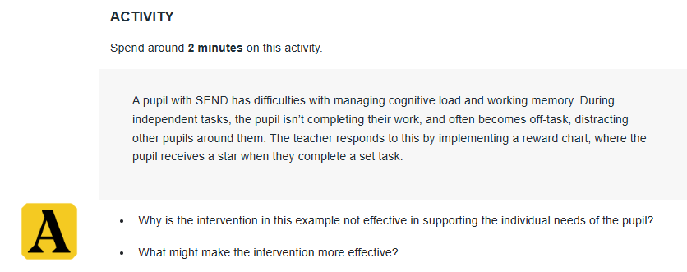
This is what we think:
- The intervention should be targeted at addressing the need of the individual. The reason for the pupil’s off-task behaviour is likely that they are struggling to engage due to the cognitive demands of the tasks. The incentive of a star for completing a task alone does not support in avoiding cognitive overload or in aiding working memory.
- It’s likely that an effective intervention for this pupil would focus on providing additional support such as scaffolds to complete the task. This might then be supported with the reward chart whilst the teacher builds their motivation in tandem with supporting their cognitive load.
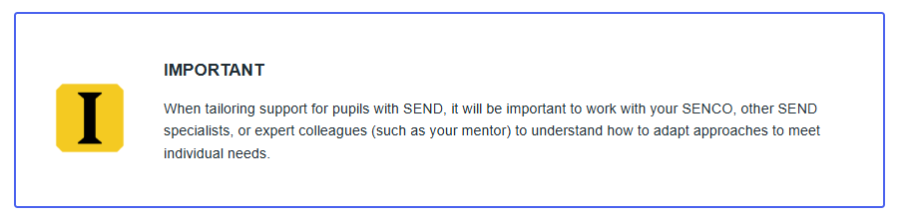
Whilst we’ve looked at an example here of a pupil with SEND, it’s important to note that pupils who need a tailored approach to support their behaviour do not necessarily have SEND. Equally, pupils with SEND will not necessarily need additional support with their behaviour.

Maintaining high expectations
Any tailored approach should always complement your school’s behaviour policy and avoid lowering expectations of pupil behaviour. The approach should not be about adjusting the desired or expected outcome - but instead adjusting how the pupil achieves this.
Pupils have an acute awareness of fairness so applying rules, sanctions and rewards consistently in line with school policy, including where individual pupils have an agreed tailored approach is key. This would mean then that consistency isn’t about a rigid and prescriptive set of rules – it’s more about the ability to provide a predictable response and applying professional judgement.

Hear from a teacher
Watch this 4-minute video as Chloe Weare, SEND Development Lead at Teach First and prior SENCO, shares how she supported a pupil who required a more tailored approach to behaviour. As you watch, consider:
- How did Chloe ensure high expectations and consistency within the tailored approach?
- Who did Chloe work with to ensure the pupils needs were met?
- What could you take from this to incorporate into your practice?

Once you've watched the video and had time to consider these questions, you can compare against our responses below.
Video - A tailored approach to behaviour
How did Chloe ensure high expectations and consistency within the tailored approach?
- Chloe ensured strategies were implemented with consistency and that they aligned with the school policy.
- She ensured that with any adaptations her expectations remained clear, but flexibility was given in how the pupil met them.
Who did Chloe work with to ensure the pupils needs were met?
- Chloe worked with the SENCO, pastoral lead and pupils’ parents to get a fuller understanding of the pupils needs and ensured that the support put in place was tailored to these.

Working with parents and carers
Building effective relationships with parents and carers can improve pupils’ motivation, behaviour and academic success. In their Teaching and Learning Toolkit, the EEF (2021) state that on average parental engagement has a positive impact of 4 months additional progress.
Parents and carers are best placed to provide crucial information about their child’s strengths and weaknesses. For example, by providing information on their child’s needs, the support they receive outside the school system, and any difficulties the child has experienced at home or elsewhere (Carroll et al. 2017).
It’s therefore crucial teachers and schools liaise with parents and carers to best meet pupils’ needs.

Barriers to parent and carer engagement
Any approaches to working with parents and carers should consider and address potential barriers to engagement. For example, considering what provision is there for working parents to engage.
Parent and carer engagement approaches also have the risk of increasing attainment and disadvantage gaps, if the parents that access the opportunities are mainly from affluent backgrounds. It is therefore key that you consider how your approach to working with parents and carers will support engagement from all parents (EEF, 2021).

Approaches to parent and carer engagement
To effectively engage parents and carers, consider how you:
- use effective communication channels which consider barriers to parent and carer engagement, for example, parent evenings, emails, drop in sessions
- tailor communications to encourage positive dialogue about learning and behaviour for example by highlighting pupil successes
- support engagement for all parents and carers, for example, by providing remote opportunities or shorter sessions for working parents/carers
- support parents and carers to ensure any home learning is high quality, for example, by carefully considering effectiveness of home learning tasks and any support parents/carers may need
- support parents/carers to ensure consistency for any approaches or interventions used at school and home, for example, by meeting to agree and discuss appropriate strategies for support

In Module 5, you’ll look in more detail at how you can work with parents and carers to understand barriers to learning and identify effective strategies for pupils with SEND.

REFLECTION
Spend around 3 minutes on this activity.
Consider a recent instance where you needed to work with a pupil’s parents or carers:
- How did you engage in positive dialogue about learning and behaviour?
- How did you work with the parents/carers to ensure consistency between any interventions and approaches in school and at home to support behaviour?
- Were there any barriers to being able to effectively engage the pupil’s parents or carers and how did you address or mitigate these?

Rebuilding and repairing relationships
When dealing with complex or challenging behaviour, there can sometimes be unintended negative impacts upon your relationship with your pupils depending on how the behaviour was dealt with. On these occasions, it is important to find time to follow these interactions up with a restorative conversation. This enables you to discuss the incident, reinforce your expectations and demonstrate that you have considered and understood your pupils’ feelings.

Hear from an expert
Listen to Tom Bennett in this 5-minute video talking about the importance of repairing relationships and holding restorative conversations to improve pupils’ behaviour. Whilst watching the video, consider the following questions. You can record your reflections using the notes tab.
- What are the three key messages you can convey during restorative conversations?
- When is the best time to hold restorative conversations?
- What are the implications for your own practice?
Video - How do you repair and build relationships?
- Key areas to address during a restorative conversation are where the pupil went wrong, what they need to do to improve, and why they are still a valued and welcome member of the classroom.
- The best time to hold these conversations depends on the misbehaviour. For smaller incidents these can be had as quickly as possible, for example, during a break or end of the lesson. For more extreme incidents, it’s important time is taken for all involved to calm down and process before the restorative conversation can take place.

REFLECTION
Think about an occasion when you think the way in which you dealt with challenging or complex behaviour might have impaired your relationship with a pupil (for example when giving consequence or sanctions). Consider the following questions and record your responses. You can record your reflections using the notes tab.
- Why do you think this interaction impaired your relationship?
- What did you do to address this and why was this effective/ineffective?
- What might you do differently next time?

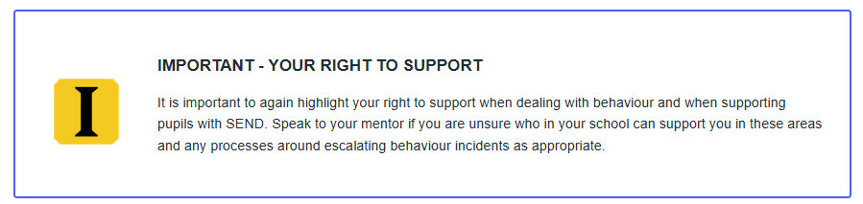

Mentor interaction: Addressing complex behaviour
In your next mentor interaction, you will have the opportunity to discuss with your mentor how to respond to complex behaviour in your school context. Complete the activity below to prepare for this.

PREPARATION
Choose one of the case studies below most relevant to your context. Spend around 10 minutes considering how you would address the pupil’s behaviour in line with your school’s policy.
Consider:
- how you would address the behaviour in the instance (consider learning from this session as well as your previous session on consequences and sanctions)
- whether tailored support may be required for the pupil and what this might look like
- who you may need to work with to support the pupils (for example, SENCO, DSL, parents/carers)
  - Early Years case study
  - Primary case study
  - Secondary case study
  - Post-16 case study
  - Special School case study

References
Carroll, J., Bradley, L., Crawford, H., Hannant, P., Johnson, H., & Thompson, A. (2017). SEN support: A rapid evidence assessment(this link opens in a new window/tab).

Clay, D., Connors, C., Day, N., Gkiza, M., and Aldridge, J. (2016) The Lives of young carers in England: Qualitative report to DfE(this link opens in a new window/tab).

Education Endowment Foundation (2019a). Improving behaviour in schools: Guidance report.(this link opens in a new window/tab)

Education Endowment Foundation (2019b). Improving social and emotional learning in primary schools: Guidance report(this link opens in a new window/tab).

Education Endowment Foundation (2021) Education Endowment Foundation Teaching and Learning Toolkit: Parental Engagement.(this link opens in a new window/tab)

Education Policy Institute (2018) Key drivers of the disadvantage gap: Literature review.(this link opens in a new window/tab)

Hall, G. (2019). The experiences of secondary school students with English as an additional language: Perceptions, priorities and pedagogy(this link opens in a new window/tab).

The Children’s Society (no date). What are the effects of child poverty?(this link opens in a new window/tab)

The National Governance Association (2024). Supporting the attainment of disadvantaged children in educational settings.

