MODULE 1- HOW CAN YOU CREATE AN EFFECTIVE LEARNING ENVIRONMENT?

SESSION 5: HOLDING HIGH EXPECTATIONS AND MAINTAINING ENGAGEMENT

Welcome to the core session: Holding high expectations and maintaining engagement.
This session should take around 45 minutes to complete.

Session overview
It is important you create a learning environment that challenges and stretches all pupils.

To support you to do this, you will explore:

- The impact of high expectations
- How to demonstrate high expectations through
  - Holding high expectations for contributions
  - Using countdowns or timers
  - Making the beginning and end of activities clear.

Impact of high expectations
“Teacher expectations play a role in shaping pupil outcomes and teachers should aim to communicate a belief in the academic potential of all pupils.”
(EEF, 2021)

Teachers are key role models who can influence the attitudes, values, and behaviours of their pupils. Evidence links teacher beliefs and expectations with pupils’ own beliefs and self-perceptions. Pupils form more positive beliefs in their own academic ability if they feel their teacher holds high expectations of them, and the reverse is true when the teacher has lower expectations (McKown & Weinstein, 2008).

The expectations you have of your pupils can also impact their progress and outcomes. Research has shown that when teachers have high expectations for their pupils, their progress and outcomes are better (Murdock-Perriera & Sedlacek 2018, Hattie 2008, Rubie-Davis et al 2014).

Think about your classroom practice and make a note the following questions. You can record your reflections using the notes tab.
- Do you have high behavioural and academic expectations for all your pupils or do your behavioural and academic expectations differ for different pupils?
- Why do you think this is and what impact might this be having on your pupils’ progress and outcomes?

High quality teaching
High expectations for all pupils can be delivered through high quality teaching. Teachers with high expectations tend to offer more challenging learning experiences, constructive feedback, leading to increased pupil motivation and improved academic outcomes (Rubie-Davies et al., 2014).
Research shows that high quality teaching has a long-term positive impact on pupils’ life chances particularly for pupils from disadvantaged backgrounds (Sutton Trust, 2011) and is underpinned by positive interactions between pupils, their teachers and their peers (Cullen et al, 2020).
Setting clear expectations helps to communicate to your pupils what you expect of them. Through doing this, you can convey the values of your classroom and school, which can help in creating a positive learning environment and culture. You should spend some time considering what your behavioural and academic expectations are. It might be useful to discuss these with your mentor to ensure they are fitting and align with your school’s behaviour policy.
Throughout this programme the approaches and strategies you’ll explore are all part of high quality teaching.

High expectations for contributions and concentration
One way you can communicate your high expectations and belief in the academic potential of all pupils is through the use of intentional and consistent language which promotes challenge and aspiration. In your session on developing motivation, you explored how this might look through praising effort rather than intelligence, using language which creates an environment where it’s safe to make mistakes, and discussing long-term goals with pupils.
Here we will focus on how you can ensure high expectations for all pupils through teaching and maintaining clear expectations for contributions and concentration.
When considering the level of concentration and contributions that you expect from your pupils, it is helpful to consider the concept of ratio. This can be broken down into two parts:
- Participation ratio - how many pupils in the classroom are participating in the task. The ideal here is every pupil.
- Think-ratio - the level of rigour in the thinking and engagement that you foster in your pupils.

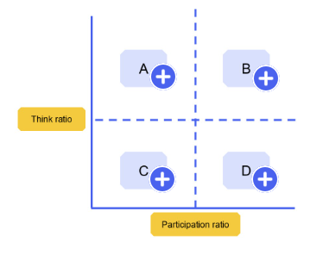
A = High level of thinking + low level of participation
B = High level of thinking + high level of participation
C = Low Level of thinking + low level of participation
D = Low level of thinking + high level of participation

The goal is to get to point B on the graph below, where you have both a high participation and high think ratio in your classroom. To do this you must demonstrate high expectations of all your pupils, expecting everyone to concentrate and participate in your lesson. This will maximise learning and progress for all pupils, helping them to achieve, feel success and therefore feel motivated to continue participating.

How can you implement the high expectations that you hold?
Holding and rigorously maintaining high expectations is important but knowing how to implement them in the classroom and demonstrate them to your pupils can be challenging.
In the next part of this session, you will explore some strategies that will help you demonstrate high expectations for engagement and motivate pupils to remain focused, such as:
- Using questioning.
- Using countdowns or timers.
- Making the beginning and end of activities clear.

Using questioning
One way to ensure you’re communicating high expectations for all pupils is by setting the expectation that all pupils should be prepared to contribute during a lesson if asked to do so. This encourages pupils to take responsibility for learning and emphasises the importance of trying, even if a pupil is unsure of their response. It is quite common in this scenario for a pupil not to answer or to say, “I don’t know”.

How to support pupils to respond
When asking questions during a lesson, if a pupil doesn’t respond or says, “I don’t know”, there are several ways you can support them to answer the question, such as.
PROVIDE A HINT OR PROMPT
For example: “Are there any words on the word wall that could help you?”

ASK ANOTHER PUPIL TO GIVE A HINT OR PROMPT
For example: “Hamish, can you support Amel by starting us off with the first number in the sequence?”, then returning to Amel for the next part of the sequence.

ASK ANOTHER PUPIL TO ANSWER – THEN GO BACK TO THE ORIGINAL PUPIL
For example: “That’s okay, Georgia. Javid, can you tell us what year the Great Fire of London happened? … Great, thank you. Georgia, can you repeat what Javid said? Perfect, thank you.”

This helps to build a culture of engagement and inclusion. It also clearly conveys to your pupils that you expect them to remain focused during your lesson so they can be successful in their learning.

Using questioning to support high expectations for contributions in action
Spend around 5 minutes on this activity.
Watch one of the videos below to see how teachers hold and demonstrate high expectations for contributions in the classroom. As you watch consider the following questions. You can record your reflections using the notes tool.
- Which of the approaches does the teacher use?
- What makes it effective?

Now watch the video most relevant to your phase or context.

Primary video
Secondary video
Post-16 video
Special school video

Using countdowns or timers
It’s important pupils in your class recognise learning time is valuable and that you expect them to work purposefully throughout the lesson or day. One way to support you to communicate high expectations when it comes to pupil engagement in their activities is to share the duration of time that pupils have to complete certain activities.

What are the benefits of this?
- It supports the pupils to remain focused on learning
- It can create a sense of achievement when pupils complete a task in the time
- It supports pupils to manage their learning time
- It supports the pace of the lesson, helping you as a teacher to keep the lesson on track

How to use a timer effectively
You can use a timer for almost all classroom activities whether they are academic or not. Using a timer works best if you:
- state how long pupils have
- state what pupils are expected to do in this time
- visibly share the timer and refer to it
- provide check points along the way, for example, “You should be at question 5 by now”

Using countdowns or timers in action
Spend around 5 minutes on this activity.
Watch one of the videos below to see a teacher using a countdown or timers in the classroom and make a note of the following points. You can record your reflections using the notes tool.
- How did the teacher use the timer effectively?
- Were there any parts that could be improved?

Now watch the video most relevant to your phase or context.

Early Years video
Primary video
Secondary video
Post-16 video

Making the start and end of activities clear
Another way to support pupils to stay focused and engaged during lessons, and to therefore reinforce your high expectations, is to make the start and end of activities clear. This can help to keep the pace of the lesson and keep pupils alert and focused.
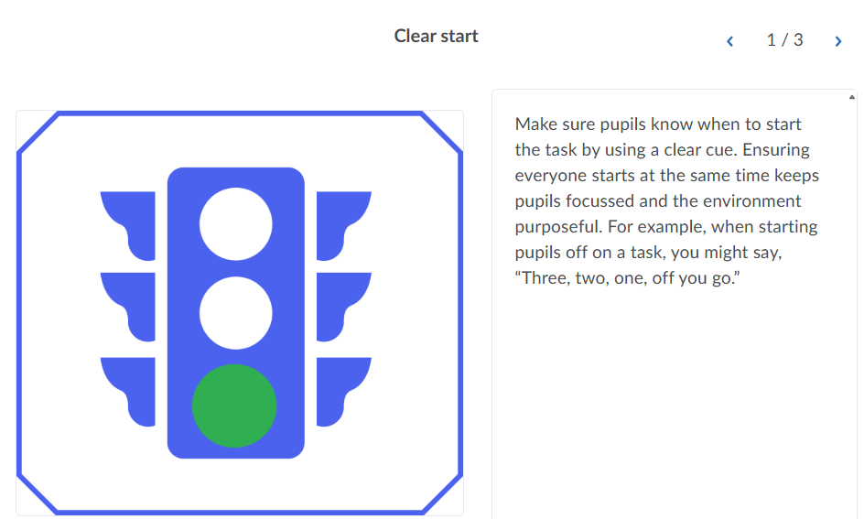

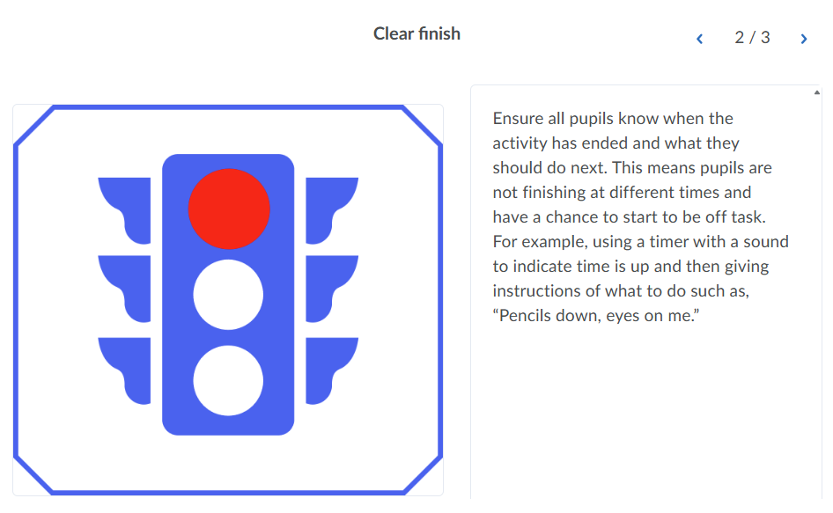

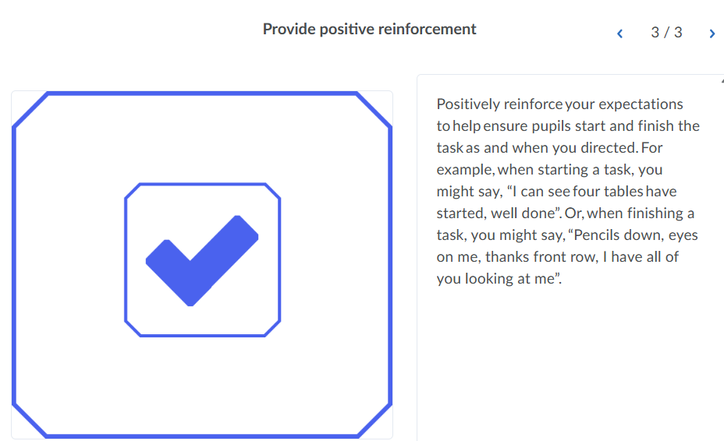

Making the beginning and end of activities clear in action
Spend around 5 minutes on this activity.
Choose one of the videos below to watch teachers make the beginning and end of activities clear. As you are watching, make a note on the following questions. You can record your reflections using the notes tab.
- How has the teacher ensured a clear start or finish?
- How do they reinforce their expectations?

Select the video most relevant to your phase or context.
Early years video
Primary video
Secondary video
Special school video

Mentor interaction: Least invasive interventions
In preparation for your next mentor interaction, your mentor may observe how you hold high expectations and maintain high levels of engagement with your pupils. You and your mentor should focus their observation on one of the strategies covered in this session. As a reminder these were:
- Using questioning to support high expectations for contributions
- Using countdowns or timers
- Making the start and end of activities clear

PREPARATION
To prepare for your observation, take around 10 minutes to plan how you will demonstrate high expectations and maintain high levels of engagement by using one of the techniques outlined below. Use the success criteria of the technique to support you to script what you might say.

Success criteria

Using questioning to support high expectations for contributions
- providing a hint or prompt to support them to contribute
- asking another pupil to give a hint to help them to respond
- asking another pupil to answer, and then go back to the original pupil to repeat or add to their response

Using countdown or timers
- state how long pupils have
- state what pupils are expected to do in this time
- visibly share the timer and refer to it - for younger pupils this might be in the form of a sand timer and for older pupils this might be in the form of a countdown clock.
- provide check points along the way, for example, “You should be at question 5 by now”

Making the beginning and end of activities clear
- clear start
- clear finish
- provide positive reinforcement

References
Hattie, J. (2008). Visible learning: a synthesis of meta-analyses relating to achievement. London, Routledge.
Lemov, D. and Atkins, N., (2015). Teach Like A Champion 2.0. San Francisco: Jossey-Bass.
Lemov, D. (2021). Teach like a champion 3.0. San Francisco: Jossey-Bass
Murdock-Perriera, L. A., & Sedlacek, Q. C. (2018) Questioning Pygmalion in the twenty-first century: the formation, transmission, and attributional influence of teacher expectancies.(this link opens in a new window/tab) Social Psychology of Education, 21(3), 691–707.
Rubie-Davies, C. M., Weinstein, R. S., Huang, F. L., Gregory, A., Cowan, P. A., & Cowan, C. P. (2014) Successive teacher expectation effects across the early school years.(this link opens in a new window/tab) Journal of Applied Developmental Psychology, 35(3), 181–191.
Sutton Trust (2011). Improving the impact of teachers on pupil achievement in the UK – interim findings(this link opens in a new window/tab).

