- Go to website : https://www.register-early-career-teachers.education.gov.uk/
- Continue to DfE Sign-in :
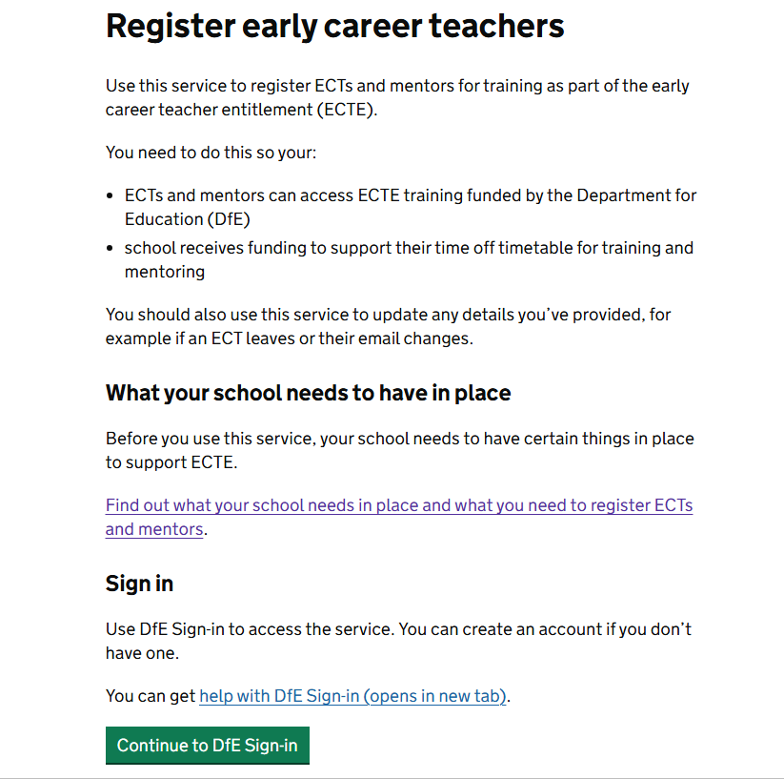
- If you have access to DfE sign for other school purposes then log into your account
- If you do not already have access to the DfE sign-in then you will need to “Create an account” – use your school email address for this, you should receive a verification code to your email address as part of this setup process.
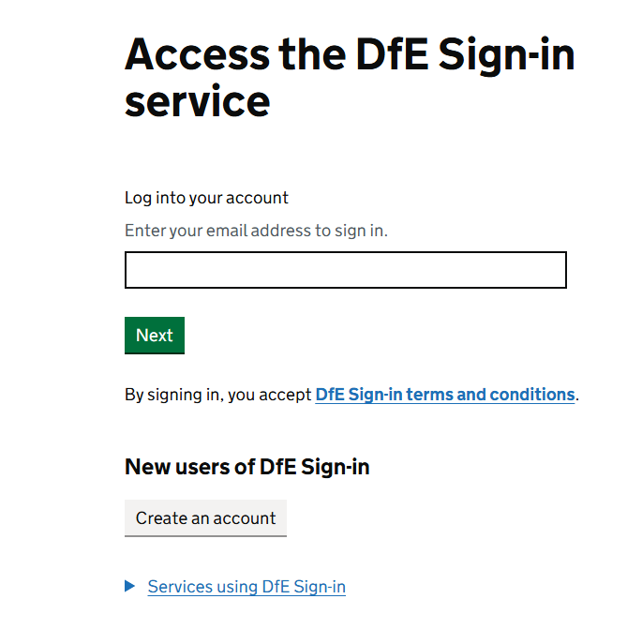
- This is an example of what you will see when you have created an account, then you need to request access to an organisation, click “Next Action”:
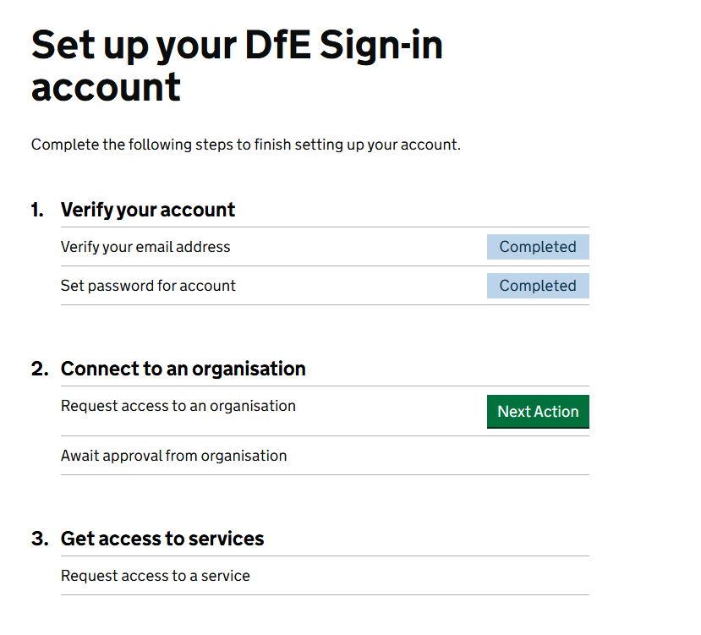
- Type in your school’s name and request access. You will then receive an email similar to this with your school’s name:
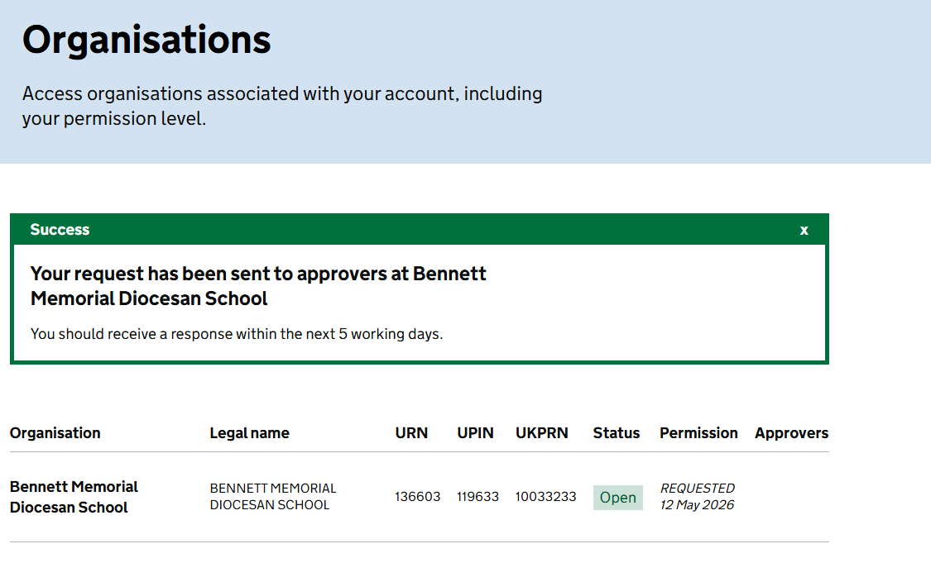
- In the meantime, the person in your school that manages the DfE sign-in for different services will have received an email requesting access from the DfE for you.
- When they have confirmed you as an authorised user, you will then be able to “Request access to a service”
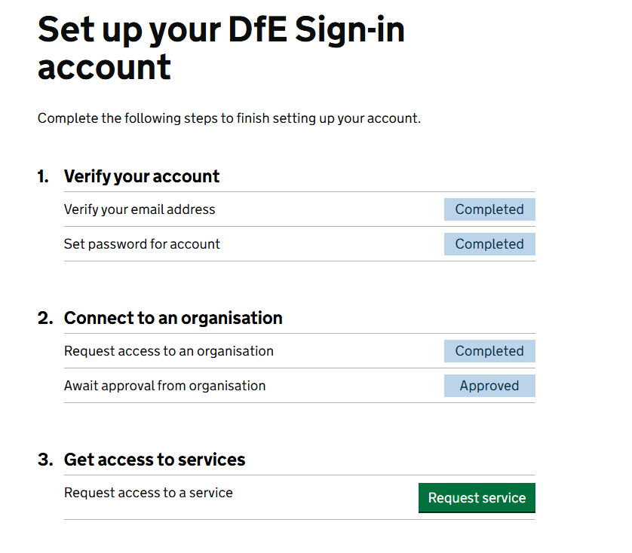
- When you 'request a service', you need to scroll down the alphabetical list to “Register early career teachers”
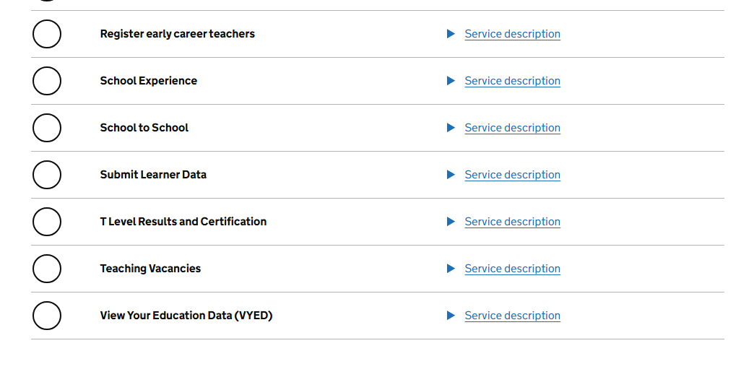
- The person in your organisation with DfE sign in authority needs to then “Manage Users” and select the following for you:


