Useful Links – click on icons below:
Xavier Bulletin  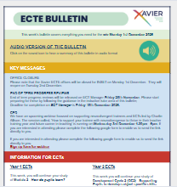 | Brightspace – Mentors   | Brightspace – ECT2s  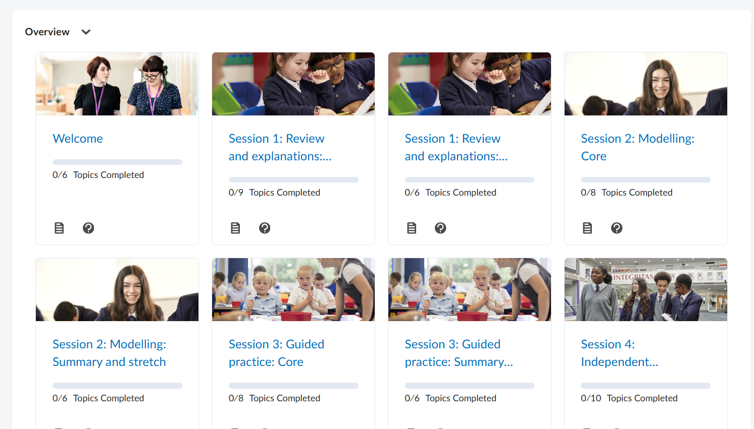 | Seminar Topics  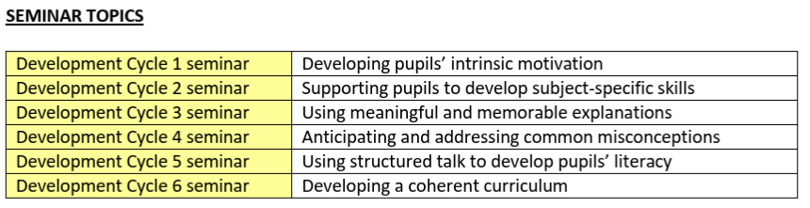
Xavier TS Hub website Member Area: home page | email: xavierecf@xavier.org.uk | Password: Xaviertsh2024
Meeting Prompts:
Wellbeing check:  - How has your fortnight been?  - How are you managing your workload at the moment?  - Is there anything we can put in place to support you in the coming fortnight? |  | Notes:
Last fortnight’s focus:  - Check Brightspace together (see above links)  - What was the focus?  - Progress on Brightspace tasks?  - Discuss impact of focus on practice. |  | Notes:
This fortnight’s focus:  - Check Brightspace together (see above links)  - What is the focus?  - Discuss ideas of embedding focus on practice. |  | Notes:
Instructional coaching focus for this meeting  Using the Feedback Model and question prompts:  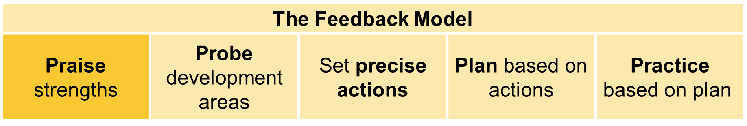  - What I thought worked well was…  - What areas do you still feel need developing?  - How could you improve that area?  - What would you like to see happen instead?  - What strategies could you use?  - What would the impact of that be? |  | Notes:
Other discussion points (if appropriate):  - Discuss key learning from ECT seminar.  - What impact will learning have on practice?  - Future dates/deadlines.  - End of term Progress Review/Assessment. |  | Notes:
Summary of key take aways from either:  - Drop-in lesson observation of the ECT, or  - Expert colleague observation/discussion |  | Notes:
Agreed actions for the next two weeks:

