

17th April 2023

Dear April-starter Early Career Teachers (ECTs),

We are delighted that your school has chosen to work with the Xavier Teaching School Hub in delivering the Teach First Early Career Framework (ECF) programme and very much look forward to working with you. We are excited to help you get off to the best possible start to your teaching career.

Statutory induction has been designed by the Department for Education (DfE) to be a bridge between initial teacher training and a career in teaching. It combines a structured programme of development, support and professional dialogue, underpinned by the Early Career Framework (ECF), with monitoring and assessment of performance against the Teachers’ Standards.

1 TRAINING

Training has two main elements:

- Seminar attendance (2 twilight, face-to-face seminars per half-term)
- Completion of online modules through Brightspace, Teach First’s online training platform (one module per half-term).

1.1 Twilight, face-to-face seminars

ECTs who began the programme in September 2022 or January 2023 are currently studying Module 5 and will move onto Module 6 after the May half-term. Module 1 seminars will not run again until the autumn term, when next year’s ECTs join the programme. For this reason, you will not be required to attend any face-to-face seminars until September, when you will join in with the 2023-24 training cohort (see the table below).

Seminars materials have been developed by Teach First and are delivered in your locality by Xavier’s ‘delivery partner’ schools, all of which have been chosen for their excellence. By July 2023, you will be notified of the dates, times and locations of your twilight seminars for the autumn term and beyond.

Term | Summer Term 1 | Summer Term 2 | Autumn  Term 1 | Autumn  Term 2 | Spring  Term 1 | Spring Term 2 | Summer Term 1 | Summer Term 2
Dates | Apr-May 2023 | May-Jul  2023 | Sep-Oct  2023 | Oct-Dec  2023 | Jan-Feb  2024 | Feb-Apr  2024 | Apr-May 2024 | May-Jul  2024
Online modules | Induction and Module 1 |  |  | Module 2 | Module 3 | Module 4 | Module 5 | Module 6
Face-to-face seminars | - |  | Module 1 | Module 2 | Module 3 | Module 4 | Module 5 | Module 6

The twilight seminars ECTs attend relate to the online study module they are working on at the time.

1.2 Online modules

In their first year on the ECF programme, ECTs complete online induction and 6 additional modules. Your Brightspace study sessions are as follows:

Module | Module Title | Terms
Induction |  | 2023: Summer 1, Summer 2, Autumn 1
1 | How can you create an effective learning environment | 2023: Summer 1, Summer 2, Autumn 1
2 | How do pupils learn? | 2023: Autumn 2
3 | What makes classroom practice effective? | 2024: Spring 1
4 | How can you use assessment and feedback to greatest effect? | 2024: Spring 2
5 | How can you support all pupils to succeed? | 2024: Summer 1
6 | How can you plan a coherent curriculum | 2024: Summer 2

ECTs starting the programme in April 2023 will follow a different training pathway than those ECTs who started earlier in the year, up until the October 2023 half-term, after which they will join the September 2023-starter training cohort for the start of Module 2.

The content of the modules has been developed by Teach First and is accessed via their online learning platform, known as Brightspace. You should have received your Brightspace login directly from Teach First. If you have not yet done so, please email Teach First (see paragraph 3.6 below), after checking your junk mail folder. If access is not resolved after two weeks, please notify Kate du Toit by emailing k.dutoit@xaviercet.org.uk.

April-starter ECTs benefit from a much longer period of time in which to complete the online induction and Module 1 training materials. This presents a very valuable opportunity for you to spend time focusing on settling into your schools and getting to know your new class(es), before being required to follow a more intense training programme from October 2023.

2 ASSESSMENT

The training and support you receive throughout induction has been designed to ensure that you can demonstrate that your performance against the Teachers’ Standards is satisfactory by the end of induction.

The final decision as to whether you have satisfactorily met the Teacher’ Standards, based on your headteacher’s recommendation at the end of your 2-year induction, sits with the Xavier Teaching School Hub, who act as the ‘appropriate body’ (AB). The role of the AB is to ensure that ECTs receive their statutory entitlements, including the receipt of a programme of support and training based on the ECF, as well as ensuring that ECTs are fairly and consistently assessed. The AB informs the Teaching Regulation Agency (TRA) when you start induction and confirms to the TRA the outcome of your induction period.

Please find below the assessment timetable for those ECTs starting in April 2023:

Term | End of Summer Term | End of Autumn Term | End of Spring  Term | End of Summer Term | End of Autumn Term | End of Spring  Term
Dates | Jul 2023 | Dec 2023 | Mar 2024 | Jul 2024 | Dec 2024 | Mar 2024
Type of assessment | Progress review | Progress review | Formal assessment | Progress review | Progress review | Formal assessment (completion of induction)

2.1 Progress reviews

At the end of terms 1, 2, 4 and 5 of your six-term induction, your school will review your progress against some of the Teachers’ Standards with you. Following the review, school leaders will write a short report which they will then upload to ECT Manager, Xavier’s online assessment portal. A progress review is exactly what it says – simply a review of how you are progressing as a teacher. A progress review is not a formal assessment – it is designed to celebrate progress, provide ‘next steps’ guidance and flag any areas of concern, so that further support can be put in place, if necessary. The process is very transparent. The school completes the progress review, which you then have the opportunity to read and comment on. Every completed report is then read and monitored by the AB team at Xavier.

2.2 Formal assessment

At the end of terms 3 and 6, ie at the end of the first and second years of induction, a formal assessment is carried out by your school, which always includes an observation and professional discussion. ECTs are asked to provide evidence to their school leaders of their progress against the Teachers’ Standards to inform the discussion. School leaders then write a more comprehensive report regarding your progress against all of the Teacher’s Standards, which they upload to ECT Manager. As with progress reviews, you will have the opportunity to read and comment on the report, before the completed report is read and monitored by the AB. Again, assessments are designed to celebrate progress, provide ‘next steps’ guidance and flag any areas of concern.

2.3 ECT Manager

Once your school has set you up on ECT Manager, you will receive an email containing your login details. If, by the time of your first progress review, you have not received your login, please email Alison Maingard on a.maingard@xaviercet.org.uk. Please note that mentors do not have access to ECT Manager, as they do not complete the written reports.

2.4 Part-time ECTs

If you are on a part-time contract, you will have a progress review each term. However, your formal end-of-year-1 assessment will not take place until you have completed the full-time equivalent of three terms. It is therefore possible that you may have a progress review and an assessment in the same term. As part-time contracts vary greatly in terms of hours of employment, the Xavier team will be pleased to discuss assessment and training timelines with you on an individual basis. Please do not hesitate to get in touch, if you are on a part-time contract and would like further detail.

3 QUESTIONS YOU MAY HAVE

3.1 Where can I find the induction modules I need to complete?

Session | Location
1 – The Teach First Early Career Framework Programme | https://youtu.be/mLT00P-F9ds
2 – Developing your expertise | Brightspace
3 – An introduction to instructional coaching | https://youtu.be/ZN0SMdqzBQw
4 – Using praise and consequences effectively | Topic of first face-to-face seminar in the autumn term
5 – Your wellbeing | Brightspace

3.2 What support can I expect as an ECT in my first year?

As an early career teacher you have a number of entitlements. You are entitled to:

√ | have been appointed to a post that is suitable for induction, ie it provides you with the necessary tasks, experience and support to enable you to demonstrate satisfactory performance against the Teachers’ Standards.
√ | a 20% timetable reduction (reducing to 15% in your second year), compared with the timetable of the school’s existing teachers on the main pay range. This comprises:  - a 10% reduction in respect of planning, preparation and assessment time (PPA), the same as all teachers receive;  - an additional 10% reduction in respect of being an ECT (reducing to 5% in your second year of induction). This time ‘off timetable’ should be used to specifically enable you to undertake activities in your induction programme.
√ | an induction tutor who will oversee your progress and be your first point of call for answering any questions
√ | a designated mentor who will meet with you once a week for approximately an hour, to discuss your progress and support you on the programme.
√ | weekly interactions with your mentor in the form of a short lesson observation or professional discussion.
√ | an ECF training programme, provided by Xavier in partnership with Teach First, including access to Brightspace (Teach First’s online learning platform), as well as high-quality seminars, delivered by partner schools.
√ | opportunities to observe experienced teachers.
√ | regular observations of your teaching practice.
√ | a named contact at the appropriate body with whom you can raise any concerns about your induction programme that you are unable to resolve. See paragraph 3.11.

Every school manages their ECTs’ entitlements in a manner which best fits the school’s individual context. If you have any questions about the above, please speak to your induction tutor in the first instance, then contact the Xavier team, if required.

3.3 How will I know what I should be doing week-by-week?

Please find attached at Appendix B a week-by-week breakdown of your programme, up until October 2023. Please do not be concerned by the fact that the breakdown begins with Week 26. This refers to Week 26 of the 2022-23 academic year, and not Week 26 of your induction programme!

3.4 How do I know which face-to-face seminar to attend?

By the end of July you will be notified of the dates, times and locations of your twilight seminars, as well as the contact details of those delivering them. If you have not received this information by the first week in September, please contact Kate du Toit on k.dutoit@xaviercet.org.uk.

3.5 What do I do if I cannot attend my seminar?

Seminar attendance is a mandatory part of the programme. In order for the DfE to fund your training, we are required to monitor and report both your attendance at seminars and your engagement with the online modules. Seminars are a phase-specific opportunity for you to share time, experiences and good practice with other ECTs in your area. Non-attendance is accepted only in exceptional circumstances. These might include parents’ evenings, residential trips, illness etc. If you are unable to attend a seminar, please

- notify your induction tutor
- let the person delivering the seminar know
- notify Kate du Toit (email above) in the Xavier office.

Kate will either direct you to an alternative face-to-face seminar or will arrange for you to receive catch-up training.

3.6 What do I do if I don’t have a Brightspace login?

Brightspace logins are issued directly by Teach First. If you have not yet received your login, please email blsupport@teachfirst.org.uk. In your email to Teach First, please include your teacher reference number (TRN), your full name and the name of the school at which you are employed.

3.7 What records do I need to keep?

It is important that you retain a copy of the following records, either by uploading them weekly onto Brightspace or by keeping them in a suitable ring-binder or other folder:

- weekly mentor meetings
- observations.

Templates for both can be downloaded from the secure area of the Xavier Teaching School Hub website. See paragraph 3.8 below. If your school prefers to use their own proforma for lesson observations, that is fine. There is no need to transfer this information to the Xavier form. Records of weekly mentor meetings should be ‘living’ documents – there is no need for them to be typed, written in calligraphy script or include full sentences! Rather, they should be meaningful and should be used to document progress and inform future development of your teaching practice.

3.8 How can I access the secure area of the Xavier Teaching School Hub website?

The Xavier Teaching School Hub website can be found at https://tshub.xaviercet.org.uk. The website contains a secure area which has been specifically designed for ECTs, mentors and induction tutors.

At the top of the home screen, you will see an orange tab, entitled ECF MEMBER AREA.



You can then log in using the following details:

Email Address: xavierecf@xavier.org.uk
Password: Xaviertsh (please ensure you use a capital X)

Please do take time to familiarise yourself with the information on the secure area (click on the links in the green box).

3.9 Area there any differences if I work in a specialist (SEND) setting?

Underpinned by the belief that all teachers are teachers of pupils with special educational needs and/or disabilities, the Teach First programme offers materials and videos from specialist settings throughout the programme. ECTs who work in specialist settings are assigned to a specialist training cohort, led by one of our partner special schools. This allows them the opportunity to share good practice and to access adapted materials which better suit the needs of the pupils they teach.

3.10 If I have any questions, who do I go to?

Mentor | Induction tutor | Xavier central team | Teach First
Questions related to:  - classroom practice  - self-study and seminars  - school policies and support | Questions related to:  - the programme  - entitlements  - any additional support you may require | Questions related to:  - seminar attendance  - progress reviews and assessment  - any issues where you have spoken to your mentor and induction lead, but they have yet to be resolved | Questions related to:  - Brightspace online platform.  Contact blsupport@teachfirst.org.uk.

3.11 Who are my named contacts at Xavier?

Your first point of contact for any information, questions and concerns is the induction tutor within your school. However, the Xavier ECF and Appropriate Body team are always happy to provide advice and support. Teaching is a challenging career. Many of us are teachers ourselves and we are certainly all aware of the demands of the job, especially at the beginning of your career. We would rather intervene early and support you in the best way possible, so please do not hesitate to get in touch.



To contact the team, please either call one of the above numbers or email TeachingSchoolHub@xavercet.org.uk.

APPENDIX A – PROGRAMME OVERVIEW

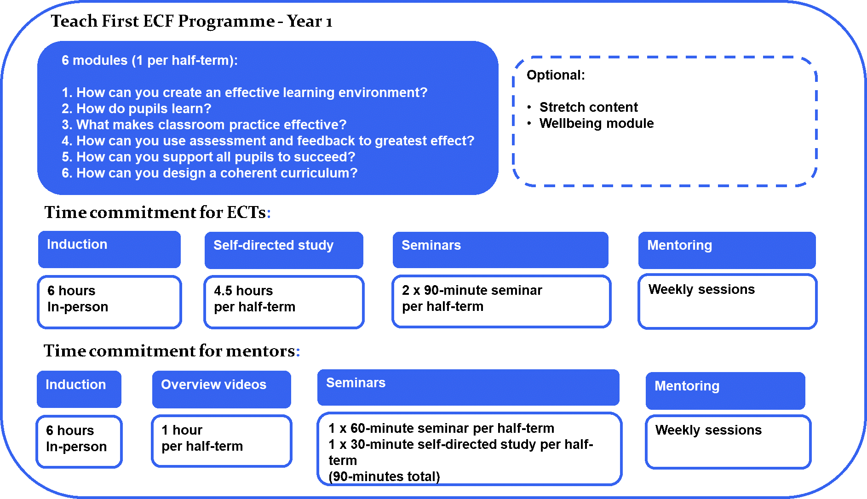

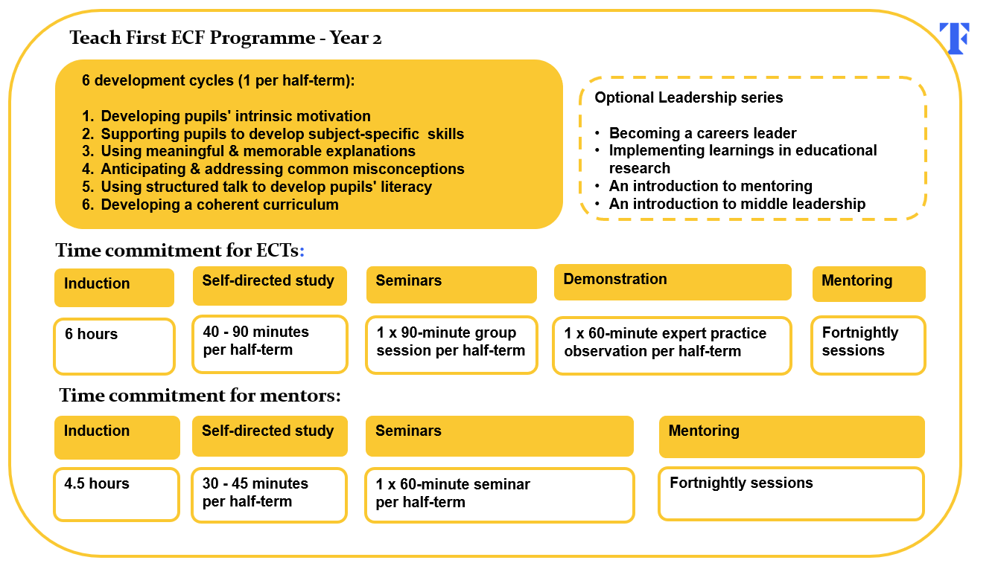

APPENDIX B – APRIL STARTERS – WEEK BY WEEK PROGRAMME

PROGRAMME OVERVIEW

ECTs starting the programme in April 2023 will follow a different training pathway than their peers up until the October 2023 half-term, after which they will join the September 2023-starter training cohort for the start of Module 2.

ECT training overview – Year 1

Module | Module Title | Terms
Induction |  | 2023: Summer 1, Summer 2, Autumn 1
1 | How can you create an effective learning environment | 2023: Summer 1, Summer 2, Autumn 1
2 | How do pupils learn? | 2023: Autumn 2
3 | What makes classroom practice effective? | 2024: Spring 1
4 | How can you use assessment and feedback to greatest effect? | 2024: Spring 2
5 | How can you support all pupils to succeed? | 2024: Summer 1
6 | How can you plan a coherent curriculum | 2024: Summer 2

ECT week by week programme

Week | Date  (week  Beginning) | Brightspace self-directed study or recording | Mentor interaction suggested focus | Face-to-face seminar at assigned location
26 | 17 Apr 2023 | School-based induction | Focus: School-based induction  (see guidance below) | -
27 | 24 Apr 2023 | ECT induction: Welcome  Brightspace | Focus: Initial interaction  (see guidance below) | -
28 | 1 May 2023 | ECT induction 1: The Teach First Early Career Framework programme  Recording | Focus: Reflection and looking ahead  (see guidance below) | -
29 | 8 May 2023 | ECT induction 2: Developing your expertise  Brightspace | Focus: Mentoring and teacher development (see guidance below) | -
30 | 15 May 2023 | ECT induction 3: An introduction to instructional coaching  Recording | Focus: Instructional coaching  (see guidance below) | -
31 | 22 May 2023
HALF-TERM
32 | 5 Jun 2023 |  |  | -
33 | 12 Jun 2023 | Module 1: Establishing effective classroom routines | Focus: Effective entry and settling routines  (see p12 of the 2022-23 mentor handbook) | -
34 | 19 Jun 2023 |  |  | -
35 | 26 Jun 2023 | Module 1: Developing motivation through a supportive environment | Focus: Precise praise and acknowledgement  (see p15 of the 2022-23 mentor handbook) | -
36 | 3 Jul 2023 |  |  | -
37 | 10 Jul 2023 | Module 1: Addressing low-level disruption | Focus: Positive and least invasive behaviour management strategies  (see p18 of the 2022-23 mentor handbook) | -
38 | 17 Jul 2023 |  |  | -
SUMMER HOLIDAYS
1 | 4 Sep 2023
2 | 11 Sep 2023 |  |  | ECT induction:  Meet and greet  ECT Induction 5: Your well-being
3 | 18 Sep 2023 | Module 1: Addressing persistent and challenging behaviour | Focus: Addressing persistent and challenging behaviour  (see p21 of the 2022-23 mentor handbook)
4 | 25 Sep 2023 |  |  | ECT Module 1 Seminar 1 (ECT induction 4): Using praise and consequences effectively
5 | 2 Oct 2023 | Module 1: Holding high expectations | Focus: Increasing pupil participation  (see p23 of the 2022-23 mentor handbook)
6 | 9 Oct 2023 |  |  | ECT Module 1 Seminar 2:  Holding high academic expectations of all pupils
7 | 16 Oct 2023

Guidance for weekly mentor meetings

WEEK 26 – week commencing 17 April 2023 – School-based induction

The first week has been allocated for mentors to ensure that ECTs have completed any required school-based induction. They should also ensure that their ECT has a clear understanding of the roles and responsibilities of those involved with their induction.

Mentors should ensure that their ECT has access to all the necessary/statutory school policies.

Discussion prompts
- Recap your school’s safeguarding process. Check that the ECT knows who to contact with any safeguarding concerns.
- Is the ECT secure in their understanding of planning responsibilities?
- Do they have any questions around the behaviour or assessment policies?

ECF links
8l. Knowing who to contact with any safeguarding concerns.

WEEK 27 – week commencing 24 April 2023 – Initial interaction

Over the next three weeks, as you begin to establish the professional relationship between ECT and mentor, you are encouraged to reflect on which areas you consider to be highest leverage for the ECT, ie what is it that the ECT most needs right now in order to be successful in their role?

In this week’s mentoring interaction, you should seek to address the following:

- Establish ways of working for the subsequent mentor interactions.
- Ensure that the ECT has identified a time each week when they will complete the online Brightspace self-study materials for their induction.

Ways of working
At the beginning of a professional mentoring relationship, it is important for both parties to discuss and establish their preferred ways of working. Establishing this early in the relationship will support the development of mutual respect, shared expectations of the process and each other, and also pre-empt any potential issues.

Use the suggested following prompts to frame your ways of working discussion:
- What do you need from me for this process to work well? What I need from you is…
- I really appreciate it when colleagues…
- What is the best way for us to regularly communicate? (e.g. email, in person, text)
- When are we happy to be communicated with/when are we not?
- What is the best time for us to schedule our interactions? (Consider timetables, staff meetings, childcare responsibilities etc.).
- What have you previously found effective in a mentor/mentee relationship?
- How can we ensure that drop-in observations are a positive and effective experience?

In addition:
- Review the module sequence one and discuss how this will fit into your timetables.
- Discuss the ECT’s experience during their ITT and how they expect to build on their knowledge and expertise in Year 1 of the ECF. What are the ECT’s post-ITT targets?

ECF links
8e. Reflecting on progress made, recognising strengths and weaknesses and identifying next steps for further improvement.
8n. Understanding the right to support (e.g. to deal with misbehaviour).

WEEK 28 – week commencing 1 May 2023 – Reflection and looking ahead

Each ECT will have an ITT action plan from last year and will have completed induction session 1 of the ECF. This is a good opportunity to address any common areas of development.

In this week’s mentoring interaction, you should seek to address the following:

1. Discuss the ITT action plan.
2. Based on the ECT’s ITT action plan, discuss their areas of strength and development - you may wish to relate this to their first module of the ECF which will focus on creating an effective learning environment.
3. Plan for your first observation

As part of this week’s self-directed study, ECTs has been asked to engage with the first induction session, titled ‘The Teach First Early Career Framework programme’. This session is accessed via a YouTube recording and will explain how the ECF programme will support the ECT’s professional development over the next year.

Mentors may wish to remind their ECTs to engage with the second induction session, titled ‘Developing your expertise’ ahead of next week’s mentor meeting. This session can be accessed through their Brightspace platform.

Initial observation
In Week 28, mentors will schedule a drop-in observation with their ECT with a focus on the identified areas of strength and development from this meeting. This observation will form the focus of your fifth mentor interaction focused on the use of instructional coaching and the feedback model.

Discussion prompts – questions for ECTs

- What are your targets for your first ECF year?
- Looking at the ECF sequence, which modules do you think will be particularly valuable to your development?
- Which areas of learning from your initial teacher training do you anticipate revisiting, and why do you think they are important for your development?
- What can I do to ensure the programme remains challenging?
- What were the highlights of your ITT year?
- What challenges were you able to overcome during your ITT?
- What worked well with your ITT mentor or tutor last year?

ECF links
8.2 Reflective practice, supported by feedback from and observation of experienced colleagues, professional debate, and learning from educational research, is also likely to support improvement.
8e. Reflecting on progress made, recognising strengths and weaknesses and identifying next steps for further improvement.
8n. Understanding the right to support (e.g. to deal with misbehaviour).

WEEK 29 – week commencing 8 May 2023 – Mentoring and teacher development

In order to best support their development, it is helpful to discuss the ECT’s experiences of Initial Teacher Training (ITT) and any preconceptions they may hold of the Early Career Framework. In this week’s mentoring interaction you should seek to address the following:

- Establish prior experiences of mentoring.
- Build a shared understanding on the mentoring and instructional coaching approach used in the ECF programme.

As part of this week’s self-directed study, ECTs have been asked to engage with the second induction session, titled ‘Developing your expertise’ accessed via Brightspace. This session will support them to understand the development of expertise in teaching and its links to pupil outcomes, the features of the Teach First ECF programme that will support the ECT’s development and their approach to being mentored. It is recommended this self-directed study materials form the basis of this mentoring interaction.
Within the self-directed study session, ECTs are reminded of the distinction between experience and expertise, and how years in the classroom does not equal impact on pupil outcomes, and teachers need to make conscious efforts to improve their practice. The novice to expert continuum is used as a model to describe how teachers develop competence with improved decision-making and the ability to respond to unpredictable situations that are key attributes of effective teachers. It is important ECTs recognise that being an ‘expert’ teacher is not a fixed destination but will require continual reflection and improvement. Expert teachers have rich domain-specific knowledge embedded within their long-term memory, which allows them to see classrooms differently and make intuitive decisions. A teacher who has recently completed their Initial Teacher Training will have already accrued many thousands of hours of being in a classroom, though the majority of this will be as a pupil. These experiences can shape the ECT’s development and their perception of what a teacher should be and do; these preconceptions can be helpful but also counterproductive and highlight the importance of mentoring and reflection.
Research on mentoring and mindsets has suggested that there are key attitudes, behaviours and competencies displayed by mentees that allow them to make the most out of a mentoring relationship, termed by Dr Linda Searby as the ‘mentoring mindset’. ECTs are asked to reflect on which qualities of the mentoring mindset they demonstrate and which they could develop in the future.

Discussion prompts – questions for ECTs
- What would you consider to be your strengths/areas of development as a teacher?
- What would you like to know about your mentor’s teaching experience and background?
- What qualities of the mentoring mindset do you display?

ECF links
8.1 Effective professional development is likely to be sustained over time, involve expert support or coaching and opportunities for collaboration.
8.2 Reflective practice, supported by feedback from and observation of experienced colleagues, professional debate, and learning from educational research, is also likely to support improvement.
8e. Reflecting on progress made, recognising strengths and weaknesses and identifying next steps for further improvement.
8n. Understanding the right to support (e.g. to deal with misbehaviour).

WEEK 30 – week commencing 15 May 2023 – Instructional coaching

The ECF programme uses an instructional coaching approach as the mechanism of improvement. In this week’s mentoring interaction you should seek to address the following:

- Establish prior experiences of instructional coaching.
- Build a shared understanding on the mentoring and the instructional coaching approach used in the ECF programme.
- Provide feedback on your first observation using an instructional coaching approach and the feedback model.

As part of this week’s self-directed study, ECTs have been asked to engage with the third induction session, ‘An introduction to instructional coaching’. The session is accessed via YouTube link and begins by reminding them of the role of feedback in their development and the benefits of receiving feedback well. As the feedback model will drive the weekly interaction between mentors and ECTs, it is essential that ECTs have a sound understanding of the protocol. ECTs familiar with the feedback model, through previous experience with Teach First or other programmes, may be able to share their insight in using the model.

The importance of the third stage, ‘Precise Actions’, is developed to clearer define this stage as including only one to three targets that are actionable and precise, as well as ensuring the ECT is able to discuss the ‘how’ as well as the ‘what’.

The final stage of the feedback model, ‘Practice’ is expanded to develop ECT’s understanding of what makes for effective deliberate practice. They review a video of a mentor and ECT where they are asked to draw out the key success criteria for this stage which includes:

- be up and in role
- call the shots
- respond to live feedback
- re-practise a skill
- recognise when improvements occur

You may wish to review this video again together and discuss your prior experiences of instructional coaching and deliberate practice (see supporting resources below).

Initial observation
Mentors will by now have seen their ECT’s teaching in action through their initial observation. To support ECT’s and mentor’s understanding of instructional coaching, mentors should use the information given from the observation as the basis for giving feedback through the 5 stages of the feedback model:

- praise
- probe
- precise action
- plan
- practice.

Discussion prompts – questions for ECTs
- What can your mentor do to provide feedback that will support your development?
- Why use instructional coaching?
- What does the term ‘Precise Actions’ mean to you?
- What are your prior experiences of deliberate practice?

ECF links
8e. Reflecting on progress made, recognising strengths and weaknesses and identifying next steps for further improvement.

