
Contents
Pause points 3
Developing your expertise 4
An introduction to Instructional Coaching 7
Using praise and consequences effectively 10
Your wellbeing 21

Pause points

Pause point 1
At this point, what questions do you have about the ECF programme?

What would you consider to be your strengths as a teacher?

Pause point 2
How do your previous experiences of being mentored or coached relate to the instructional coaching model used in the Teach First ECF Programme?

What actions will you take in the immediate term (days/weeks) to ensure that you are open to being mentored?

Developing your expertise

True or False?
1. Years of teaching experience is associated with pupil achievement. | True | False
2. Experts don’t think differently, they have more knowledge. | True | False
3. Expertise in teaching is built through experience. | True | False

Research on teacher development
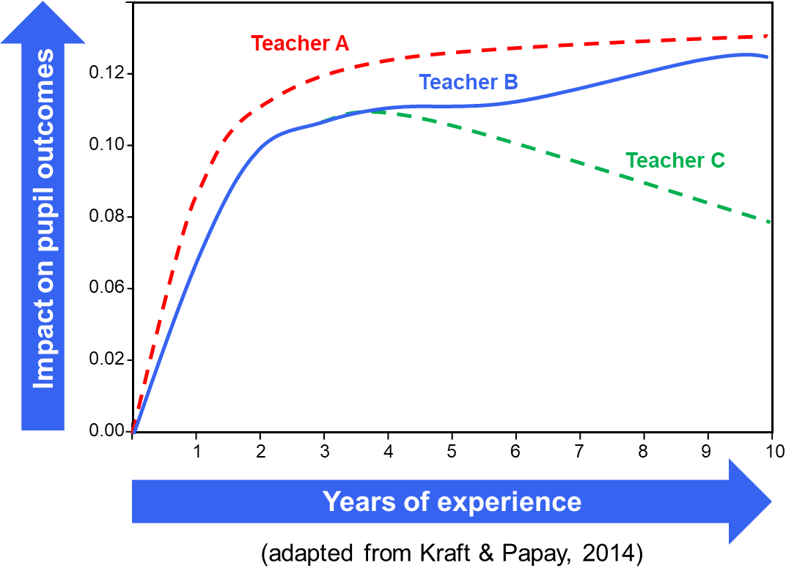

Getting better – faster
Identify and factors, from the past year, that can impact your professional development.
How did they impact your professional development?
Anchor | Barrier | Push | Pull
Make a list of any challenges that you could encounter prior to the programme starting.

Now, list down what actions you could take now to support your development

Circle of influence
Take the two lists from above and categorise them into your circle of control and influence.
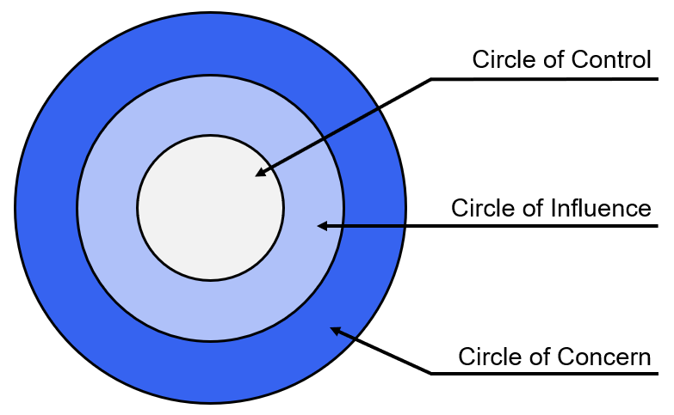

Making the most of mentoring
The table below reflects the presence of a mentoring mindset in the left-hand column and the right-hand column reflecting an absence of the mentoring mindset. For each of the indicators, based on previous experiences of being mentored, what is your own perception of whether you display the mentoring mindset. Which are areas for personal development?
Presence of mentoring mindset | Absence of mentoring mindset
Takes initiative | Lacks initiative
- Initiates contact with mentor  - Self-starter; confident  - Takes mentoring seriously  - Intentional, action-oriented | - Only responds when mentor initiates or when in crisis  - Lacks drive and motivation  - Just goes through the motions of mentoring  - Wants mentor to tell them what to do
Learning orientation | Lacks a learning orientation
- Exhibits curiosity  - Asks good questions  - Knowledgeable about concepts, content of one’s field  - Admits to not knowing everything  - Seeks & accepts feedback from mentor  - Accepts advice graciously | - No real curiosity  - Wants “quick fix answers”  - “Know it all”  - Does not take advantage of opportunities for further learning  - Rejects feedback or takes it personally  - Cannot admit weaknesses; stubborn
Skilful and organised | Lacks skill and organisation
- In goal setting, has a vision  - In organisational matters  - In time management; prioritising  - In seeing the big picture | - In goal setting, lacks vision  - In organisation matters  - In time management  - In seeing big picture
Relational | Lacks relational skills
- Can build relationships  - Knows how to network  - Notices social cues  - Approachable, positive  - Keeps lines of communication open with mentor  - Active listener  - Can keep confidences; trusts and can be trusted; honest | - No attention to building relationships  - Avoids opportunities to network  - Does not notice social cues  - Withdrawn  - Satisfied with one-way communication from the mentor  - Talks too much, does not listen well  - Struggles to build and maintain trust

An introduction to Instructional Coaching

A positive mentoring experience
Consider a time when being mentored was a positive experience for you.
What made it positive and how did your mentoring mindset influence this?

Feedback and the role of the receiver
Write down an example of when you have received the types of feedback below:
Appreciation:

Coaching:

Evaluation

The feedback model
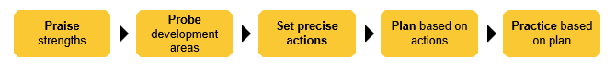

For each stage of the model, read what you can expect from your mentor and note down what you could do to ensure you are gaining the most from your mentor interactions.
Stage | What you can expect from your mentor | What could you do to be an active participant in the model? | Additional comments
Praise strengths | - Praise to be specific and precise, not lavish  - To be truthful  - To consider the impact of actions on pupils  - To reference previous actions set and progress towards them | Acknowledge the feedback is coaching
Probe development areas | - To have questions planned prior to the interaction  - To pose questions to guide you to identify an area of development  - To reference data and evidence  - To not labour this part of the model and give you more direction if needed | Listen to questions and give honest answers
Set precise actions | - To set 1-3 highest leverage actions with you  - To ensure these actions are realistic and precise  - To discuss the ‘how’ as well as the ‘what’ | Clarify the actions
Plan based on actions | - To focus on a future lesson and to identify with you where, when, and how the actions will be carried out | Manage levels of stretch
Practice based on plan | - To share clear success criteria to use  - To have a model of the technique demonstrated  - To request you to be up and in role  - To repeat the practice  - To pause and give live feedback during the practice | Make it contextually relevant

Precise actions
Scenario 1
Pupils are not all complying after being given instructions, especially during transitions.
Action: “Improve your behaviour transitions”
Precise actions:
- Review the technique Brighten Lines
- Observe it in practice
- Script in it a lesson plan for year 9
Scenario 2
Pupils are not fully understanding what they are meant to be doing in tasks.
Action: “Make sure your explanations are clear”
Precise action:
- ‘What to do’ technique. Break your instructions into two or three small steps
- Check for understanding
- Script out within lesson plan

- What are the barriers you may face with these actions? How easy or hard are they to carry out?

- What are the differences between the action and the precise action? How does this lend itself better to an ECT being able to improve their practice?

Video reflection
- How is the ECT involved in the feedback model?

- How does the practice support improvements in classroom practice?

Using praise and consequences effectively

“You make the weather”
Watch the clip of Bea Stevenson talking about emotional self-regulation. Use the question prompts provided to reflect on.

- Reflect on the relationship between daily events and emotions.

- Reflect on the relationship between emotions and behaviours.

- Reflect on the relationship between the behaviours of one individual and the emotions of others.

Emotional self-regulation
Scenario 1
John, an MFL teacher, is concerned by the results from a recent class test. He is thinking about what his Head of Department will say. Hattie, who is regularly late to lessons, and her friend are laughing when they arrive 2 minutes late to the lesson.
John: “Hattie, I’m not sure why you’re laughing when you’re late to my lesson!?”
Hattie (Rolling her eyes): “What? Am I not allowed to laugh? We got let out of computing late and it’s far!”
John: “Hattie, I don’t like your tone. That’s your warning, now be quiet and go sit down. And never roll your eyes at me again.”
Hattie: “That’s not fair! I only answered your question so why have I got a warning? I told you we were let out late!”
John: “Don’t answer back Hattie, that’s a detention now.”
Hattie swears at John, then leaves. John calls her back but Hattie swears again and keeps walking.

- How does reading this make you feel? Why?

- Where can you empathise with John?

- Where can you empathise with Hattie?

- How did emotions drive this situation?

- What key actions from John cause this situation to escalate?

- How might John have acted differently?

- How could have John managed his emotions better?

Scenario 2
Jason, who is regularly disengaged, is sitting, and staring out the window during independent work. Alex (the teacher) spent several hours the previous night preparing the work.
Alex: “Jason, get on with your work.”
Jason: “What?! I am working!”
Alex: “No you’re staring outside and don’t talk to me like that!”
Jason: “Well if you’re going to speak to me like that then I’ll speak to you like that!”
Alex: “That’s a warning, Jason. Now get on with your work.”
Jason: “I can’t. I gave my pen to Sarah last lesson, and she never gave it back.”
Alex: “That’s a poor excuse Jason. And it means that you don’t have the correct equipment so that’s detention.”
Jason storms out of the class saying that he hates school and that it’s not fair.

- How does reading this make you feel? Why?

- Where can you empathise with Alex?

- Where can you empathise with Jason?

- How did emotions drive this situation?

- What key actions from Alex cause this situation to escalate?

- How might Alex have acted differently?

- How could have Alex managed his emotions better?

Scenario 3
It is the last week of Autumn Term 2 and Abby is asking her class some retrieval questions in preparation for their end of term assessment.
Abby asks Sabba a question that she knows will be on the assessment. Sabba gives the wrong answer.
Abby: “Sabba we’ve done this so many times! How do you not know this yet?!
Another pupil sniggers under their breath.
Sabba, who always tries her best, starts to cry.

- How does reading this make you feel? Why?

- Where can you empathise with Abby?

- Where can you empathise with Sabba?

- How did emotions drive this situation?

- What key actions from Abby cause this situation to escalate?

- How might Abby have acted differently?

- How could have Abby managed his emotions better?

Scenario 4
Penny visited her ill father the previous night and was anxious all day yesterday. Tired this morning she has come in early to set up a practical science lesson for her Year 1 class.
Hezekiah is not paying attention and he breaks a thermometer.
Penny: “For goodness’ sake Hezekiah! Go sit on the carpet!”
Hezekiah: “But it was an accident.”
Penny: “It doesn’t matter if it was an accident! It wouldn't have happened if you had been paying attention, would it!”
Hezekiah sulks and refuses to go to the carpet.
Penny: “That will cost you 10 minutes of your golden time, Hezekiah!”
Hezekiah: “That’s not fair!”
Hezekiah kicks a chair.

- How does reading this make you feel? Why?
- Where can you empathise with Penny?
- Where can you empathise with Hezekiah?
- How did emotions drive this situation?
- What key actions from Penny cause this situation to escalate?
- How might Penny have acted differently?
- How could have Penny managed her emotions better?

Reflecting on your own practice
Can you think of a time when:

a) Your own behaviour in the classroom has been driven by your emotions?
b) A pupil’s behaviour was driven by your behaviour, which in turn was driven by how you were feeling?
c) Your behaviour was driven by a pupil's behaviour, which in turn was a driver for that pupil’s subsequent behaviour?
How could you have acted differently?

Your self-awareness
Checking in with your emotions:

- When can you “check-in” with your emotions?

- How could you build this into your daily routine?

- What signs might you look for to help you recognise your emotions?

Success criteria for precise praise and acknowledgement
Using the success criteria given for precise praise and acknowledgement, consider how the best practice example and the non-examples meet or fail to meet the success criteria. Write your reflections in the space provided below each example.

Precise praise
Best practice example:
“Good work Logan! I like how you’ve presented your calculation with a blank line between each step you took. I can see the exact moment you spotted your initial error and corrected it yourself.”

Non-example 1:
“Wow! Well done Logan for getting the right answer. You’re a natural!”

Non-example 2:
“Wow! Well done Logan for arriving on time. You’re so punctual!”

Acknowledgement
Best practice example 1:
“Thank you for sitting up straight, Clara. I can tell you’re ready to learn!”

Best practice example 2:
“Thank you all for entering the room so calmly and getting on with the Do Now. It really makes a difference to our learning!”

Non-example:
“Well done for sitting so nicely! You’re so polite, Clara!”

Acknowledgement or praise? Part 1
Watching the four expert teachers in the video, consider the questions given below and write your reflections in the space provided.

Consider…
- Is the teacher acknowledging, praising or both?
- What makes the praise effective in this video?
- What makes the acknowledgement effective in this video?
- How does the teacher use body language and physical actions to support?
Teacher 1:
Teacher 2:
Teacher 3:
Teacher 4:

Acknowledgement or praise? Part 2
Read each scenario and decide whether you would use acknowledgment, praise, or both. Write down exactly what you would say in the space provided below each scenario

Scenario 1:
Whilst reading aloud during a geography lesson, a pupil who struggles with their reading uses punctuation to support with intonation and expression for the first time.
“I really like how you used punctuation in the text to support with your intonation and expression – It makes it much easier for everyone else to understand. Well done!”
Scenario 2:
Jeremiah has remembered to put his hand up to ask a question instead of calling out like he often does.
Scenario 3:
During a P.E. hockey lesson, Mina manages to dribble a hockey ball between a line of cones without using the back of her stick.
Scenario 4:
During a computing lesson on cryptology, James manages to decipher a complex code using the strategy he was taught.

Scenario 5:
Dylan has been late for the last three of your lessons. Today he arrives to class on time.
Scenario 6:
While you are looking back through some pupil books you notice that Hasan’s graph drawing skills have improved significantly over the course of the term because in each subsequent graph, he drew he acted on the feedback you gave him for his previous graph.
Scenario 7:
When writing down an answer on her mini whiteboard during some whole class questioning, Bella resists the urge to show her answer before the whole class is asked to respond.
Scenario 8:
Lily repeatedly forgets to show her calculations and units when doing maths work. This time she remembers to include calculations.
Scenario 9:
During a Spanish lesson, Poppy uses the correct pronunciation third time trying. She is very pleased with herself.
Scenario 10:
Ethan usually forgets to bring his reading book and reading record to school. Today, Ethan has both. He smiles as he shows you his reading record, which shows that he read his book at home last night.

Your wellbeing

Threat, drive, and recovery
You have got some space here to write down any notes relating to the emotional regulation system.

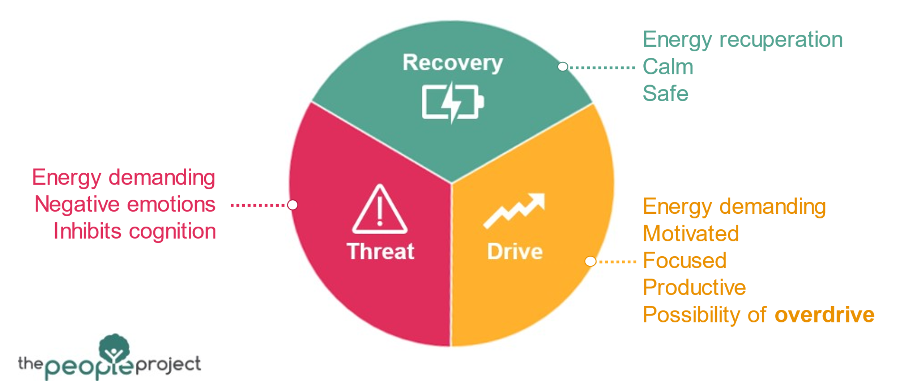

Prioritising recovery: What things could you do?
You have got some space here to write down as many things as possible that you could do to help you recover.

Do not overthink about the feasibility of your ideas; the key here is to think of as many ideas as possible!

You can use the list below to help you produce your recovery ideas.

- Escapism
- Socialising
- Mindfulness
- Sleep
- Nutrition
- Exercise
- Creativity
- Safety & familiarity



Prioritising recovery: What things will you do?

Now that you have generated a bunch of things that you could do, it is time to decide on specific things that you will do.

- Which of the ideas listed above seem the most appropriate for me?
More sleep – minimum 8 hours?
Better diet – No skipping breakfast/lunch?
- What specific actions will I take?
Eat breakfast and lunch every day.
  - Create food shop list and meal plan for the week on Sunday
  - Set breakfasts out evening before
  - Bulk cook for the week on Sundays

- When will I start?
This Sunday (30th September)
- What could happen that might stop me from taking this action?
Supermarket shops close at 4pm on Sundays – may miss the chance to buy food.
May decide to do lesson planning instead
Don’t know what to cook.
- What could I do to stop this happening?
Watch Netflix while bulk cooking.
Put tie in phone calendar to food shop in the morning and bulk cook in the afternoon.
Commit to no lesson planning in this time.


- On a scale of 1-10, how committed am I to taking this action?

Prioritising recovery: What things will you do?
Now that you have generated a bunch of things that you could do, it is time to decide on specific things that you will do.

- Which of the ideas listed above seem the most appropriate for me?

- What specific actions will I take?

- When will I start?

- What could happen that might stop me from taking this action?

- What can I do to stop this from happening?

- On a scale of 1-10, how committed am I to taking this action?

