DEVELOPMENT CYCLE 2
BRIGHTSPACE SELF STUDY

Unit 1: Development Cycle 2

Hello and welcome to Development Cycle 2: Supporting pupils to develop subject-specific skills.
This unit will support you as you work through your second development cycle.
In this unit you will find:
- an overview of Development Cycle 2
- a retrieval quiz
- a reflection to support the demonstration and deconstruction stages of the development cycle

Supporting pupils to develop subject-specific skills
Subject disciplines have unique knowledge and skills that need to be mastered. However, such skills can be challenging to teach. Therefore, the focus for your second development cycle will be on how you can teach pupils key skills within your subject or phase. The information below outlines detail about the stages of this development cycle.

Week 1: Retrieve
At the very start of the development cycle, you'll need to complete the retrieval quiz and revisit areas of the self-directed study that would benefit your development. The areas that relate most to this development cycle are:
- Module 2 – session 2: Considering how to introduce new knowledge to pupils
- Module 3 - session 2: Explanations and modelling
- Module 6 - session 2: Identifying concepts, knowledge and skills
- Module 6 - session 3: Sequencing teaching and learning
- Module 6 - session 4 and 5: Helping pupils to master important concepts, knowledge and skills
Whilst this development cycle relates to the sessions identified above, the retrieval quiz is focused on retrieving learning from Year 1, Module 2 sessions.

Weeks 1 – 2: Extend
You'll attend your second seminar which is titled: Supporting pupils to develop subject-specific skills.
In this seminar you'll explore strategies that will support you to teach pupils’ subject-specific skills. You'll explore the following strategies to support you to do this:
- Modelling using 'Think Aloud', worked examples and demonstrations
- Combining verbal and graphical representation (also known as dual coding)
These strategies will be exemplified through subject or phase specific topics.

Weeks 2 – 3: Demonstration and deconstruction
After selecting a focus area, you will observe and/or hold a discussion with an expert colleague which will be focused on your chosen area of development for this cycle. This will be followed by a second mentor interaction where you will discuss and break down the approach taken by the expert colleague.
After the demonstration and prior to the deconstruction mentor interaction you’ll complete a reflection (located within this unit). This will then be used to support the deconstruction interaction with your mentor.

Weeks 3 – 5: Integration and feedback
You’ll then integrate your new learning into your practice. The third mentor interaction, Feedback, will be structured using instructional coaching and the feedback model that was used in year one. Depending on your area of development, the stimulus for this interaction will either be an informal drop-in observation, or a discussion.

RETRIEVAL QUIZ (answers at the end)
1.

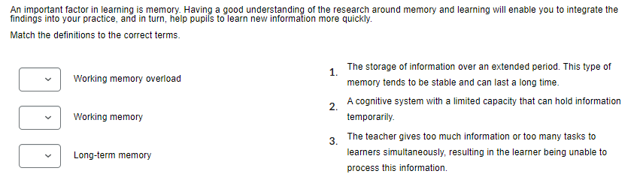

2.

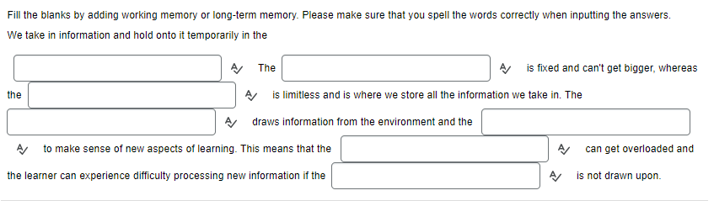

3.

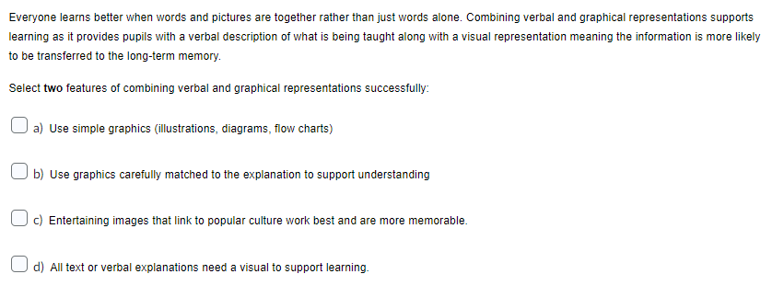

4.

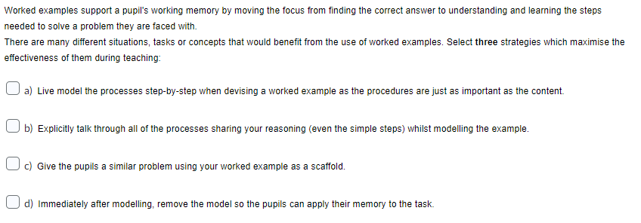

5.

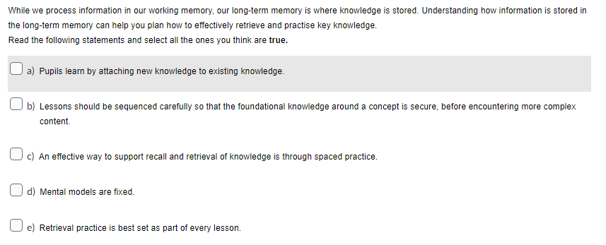

6.

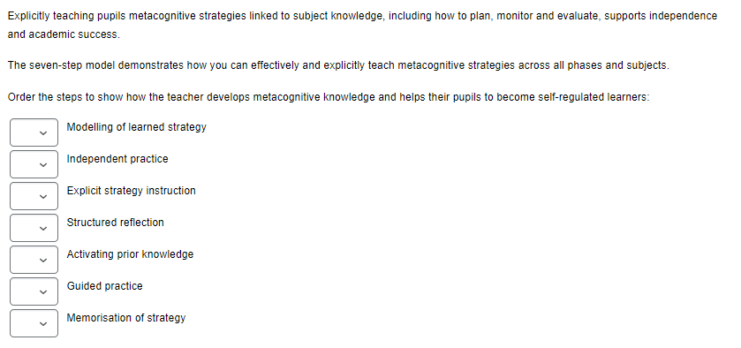

7.

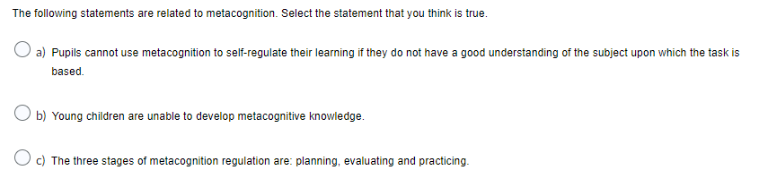

Correct answers
- 3, 2, 1
- Working memory, working memory, long-term memory, working memory, long-term memory, working memory, long-term memory
- a, b
- a, b, c
- a, b, c
- 3, 6, 2, 7, 1, 5, 4
- a

Demonstration reflection
Following your demonstration, you'll discuss your learning with your mentor as part of the deconstruction interaction. In order to ensure a focused deconstruction interaction with your mentor it’s important to spend some time reflecting on your learning from the demonstration.

Over to you!
Take some time to reflect on the demonstration in preparation for your next mentor interaction:
- What were the strengths of the demonstration?
- What further questions would you have for the teacher?
- How can your learning from this demonstration feed into your own practice?
- Consider your learning from both the seminar and the demonstration, what will you now plan to integrate into your own practice during this development cycle? This may be decided in collaboration with your mentor.
Make notes on each of these reflective prompts and share with your mentor in advance of your next mentor interaction. These reflections can then be used to support your deconstruction conversation.

